How to analyse films and clips
Films, short films, and clips are commonly used in English class alongside short stories, novels, and articles. Moreover, it is possible to choose to analyse a short film at the written exam (on English B level). Therefore, it is important that you are familiar with the most basic analysis tools for film analysis.
Below you will find the five most common analysis tools for film analysis and a definition of what they mean. Afterwards, there are training exercises in order for you to become used to using them alongside other analysis tools such as narrator, setting, and atmosphere.

Common tools for film analysis: Framing, angles, sound, lighting/colour, camera moves

Important about referencing a film or a clip
You must refer to any text you’re analysing to give the reader evidence for your interpretation. When you analyse a novel, you refer to the page (and perhaps line) of the text. When you refer to a film or a clip, you must refer to the timestamp in the following format: 00:01:45 - 00:03-17

Definitions and exercises for common tools for film analysis

Framing
Close-up | Captures the emotions and reactions of the character.  Draws attention to a specific thing.
Medium shot | Used in dialogue so that you can see the body language of the characters.
Long shot | Makes characters or objects appear small.  Gives an overview of the whole setting/situation.
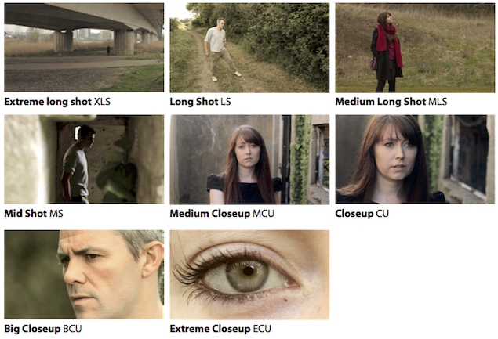
Exercise in identifying framings and their effect in this clip from Lord of the Rings - The Return of the King
Identify the framings used | Explain why those framings are used - what is the point and effect?

Angles
Eye level | The camera is placed at the same level as the characters or objects.
Low angle | The camera is placed below the person or object. This may be used to make characters look powerful and/or arrogant.
High angle | The camera is placed above the person or object. Usually, this gives the viewer a sense of overview of the scene and at the same time makes the characters and objects look small.
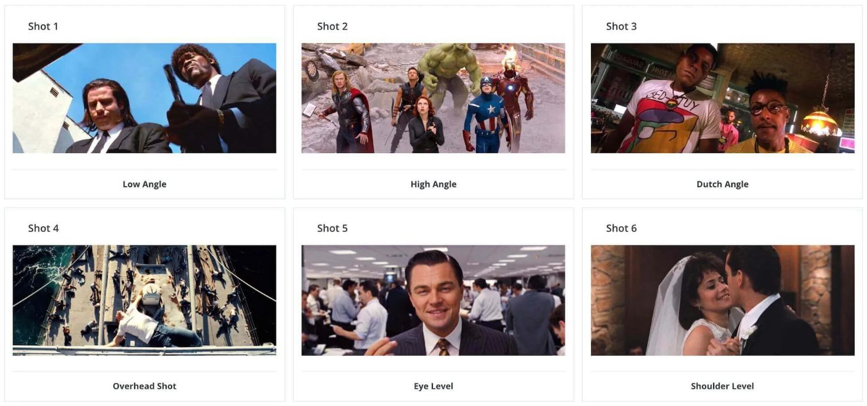
Exercise in identifying angles and their effect in this short clip from Scrubs
Identify the angles used | Explain why those framings are used - what is the point and effect?

Sound
Diegetic sound | Sound from the world of the film.
Non-diegetic sound | Sound from outside the world of the film.
Contrapuntal sound | Sound that is contrast to what is going on (e.g. happy music and a murder).
Sound effects | Non-diegetic sound effects other than music and dialogue.
Music | Non-diegetic music added to create atmosphere.
Voice-over/narration | Words spoken by somebody off-screen.
Silence | No sound.

Exercise in identifying what type of sound is used and the effect in Elemental.
Identify the types of sound  (One sound can tick more than one box) | Explain why that sound is used  What is the point and effect?

Colour/lighting
Low-key lighting: | Usually to create a tense atmosphere with suspense, mystery, or horror because of the various shadows and darkness a low-key lighting generates.
High-key lighting: | Usually to create a light-hearted atmosphere, but can be used as a contrast to earlier scenes, so that the characters need to adjust to the very lit setting.
Cold colour palette: | Usually to indicate a cold, sad, or depressing atmosphere because of the cold colours and the distance between setting and characters these generate.
Warm colour palette: | Usually to indicate a cozy and heartwarming atmosphere because of the warm colours and the closeness between the setting and characters these generate.

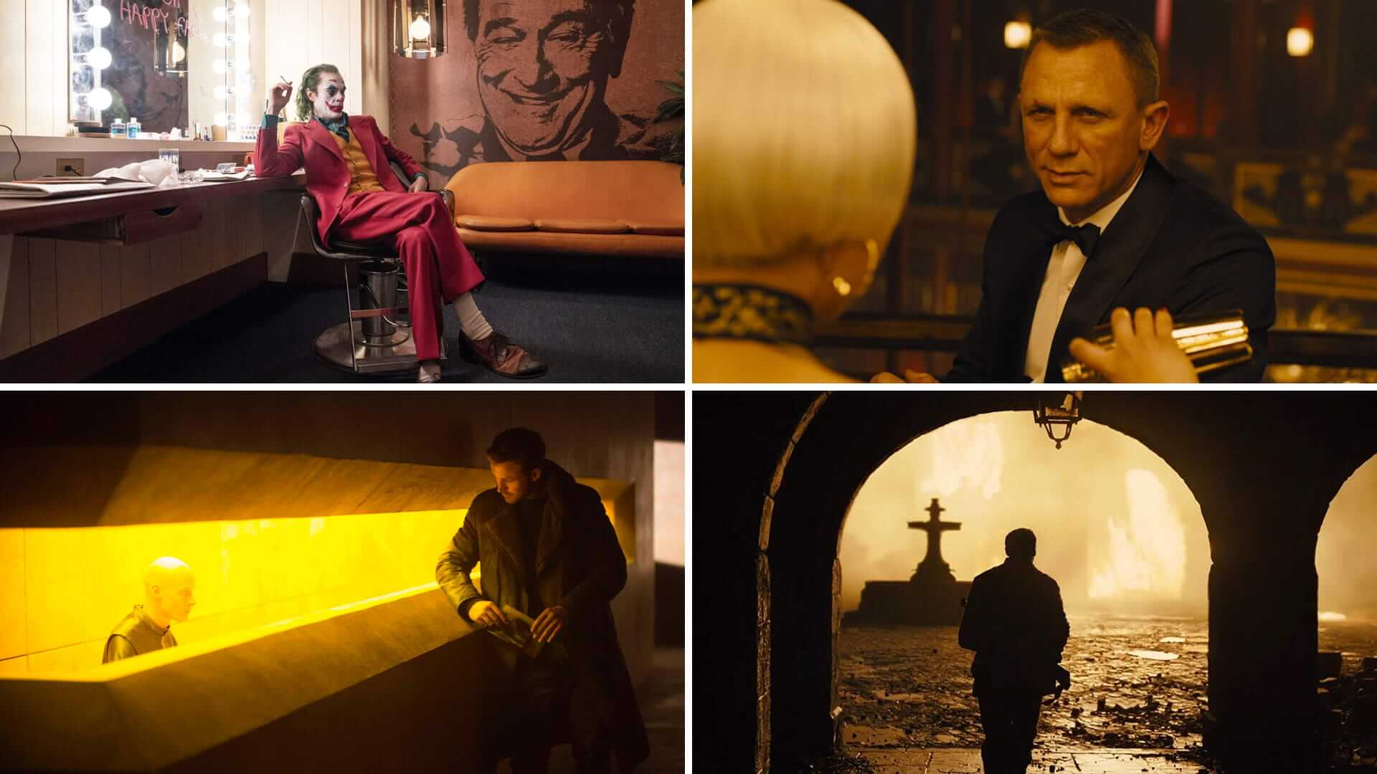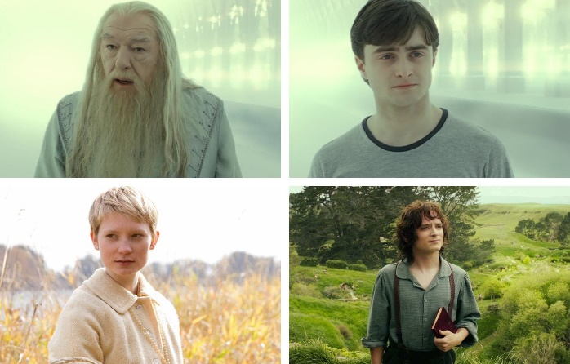
Exercise in identifying lighting and colour in the pictures above (write both lighting and colour):
Colour  Lighting | Colour  Lighting | Colour  Lighting | Colour  Lighting
Colour  Lighting | Colour  Lighting | Colour  Lighting | Colour  Lighting

Exercise in identifying lighting and colour in The Walking Dead S01E01.
Colour palettes used. (What colours are dominant? Is it cold or warm colours?) | Function of colour palettes. (What atmosphere? Suspense? Horror? Other?)
Lighting used. (What lightings are used? Is it low-key or high-key lighting?) | Function of lighting. (What atmosphere? Suspense? Horror? Other?)

Camera moves
Pan (a pan or panning): | Move the camera from side to side.
Tilt (a tilt or tilting): | Move the camera up and down.
Stationary camera: | The camera is mounted on a tripod and does not move.
Hand-held camera: | The camera moves along with a person or object in motion. Can suggest action, chaos or dizziness, but it could also be used to give the impression of something authentic.
Tracking (forward, backward, or sideways): | A tracking shot is any shot where the camera follows backward, forward or moves alongside the subject being recorded.
Zooming (in or out): | Zooming in on a character or object may, for example, invite the viewer to begin to focus on something new.

Exercise in identifying different camera moves in The Hunger Games.
Camera move used (you may use the same more than once; refer to the timestamp). | What is the effect of the camera move? Why has the director chosen this type of camera move? What does the director want to portray?

