Worksheet Ernest Hemingway - Cat in the Rain, 1925

- Read the text Cat in the Rain pages 9-12
- Plot:
Look at the word cloud below in which the short story “Cat in the Rain” is presented. Discuss in pairs your first impression of the text and summarize it briefly

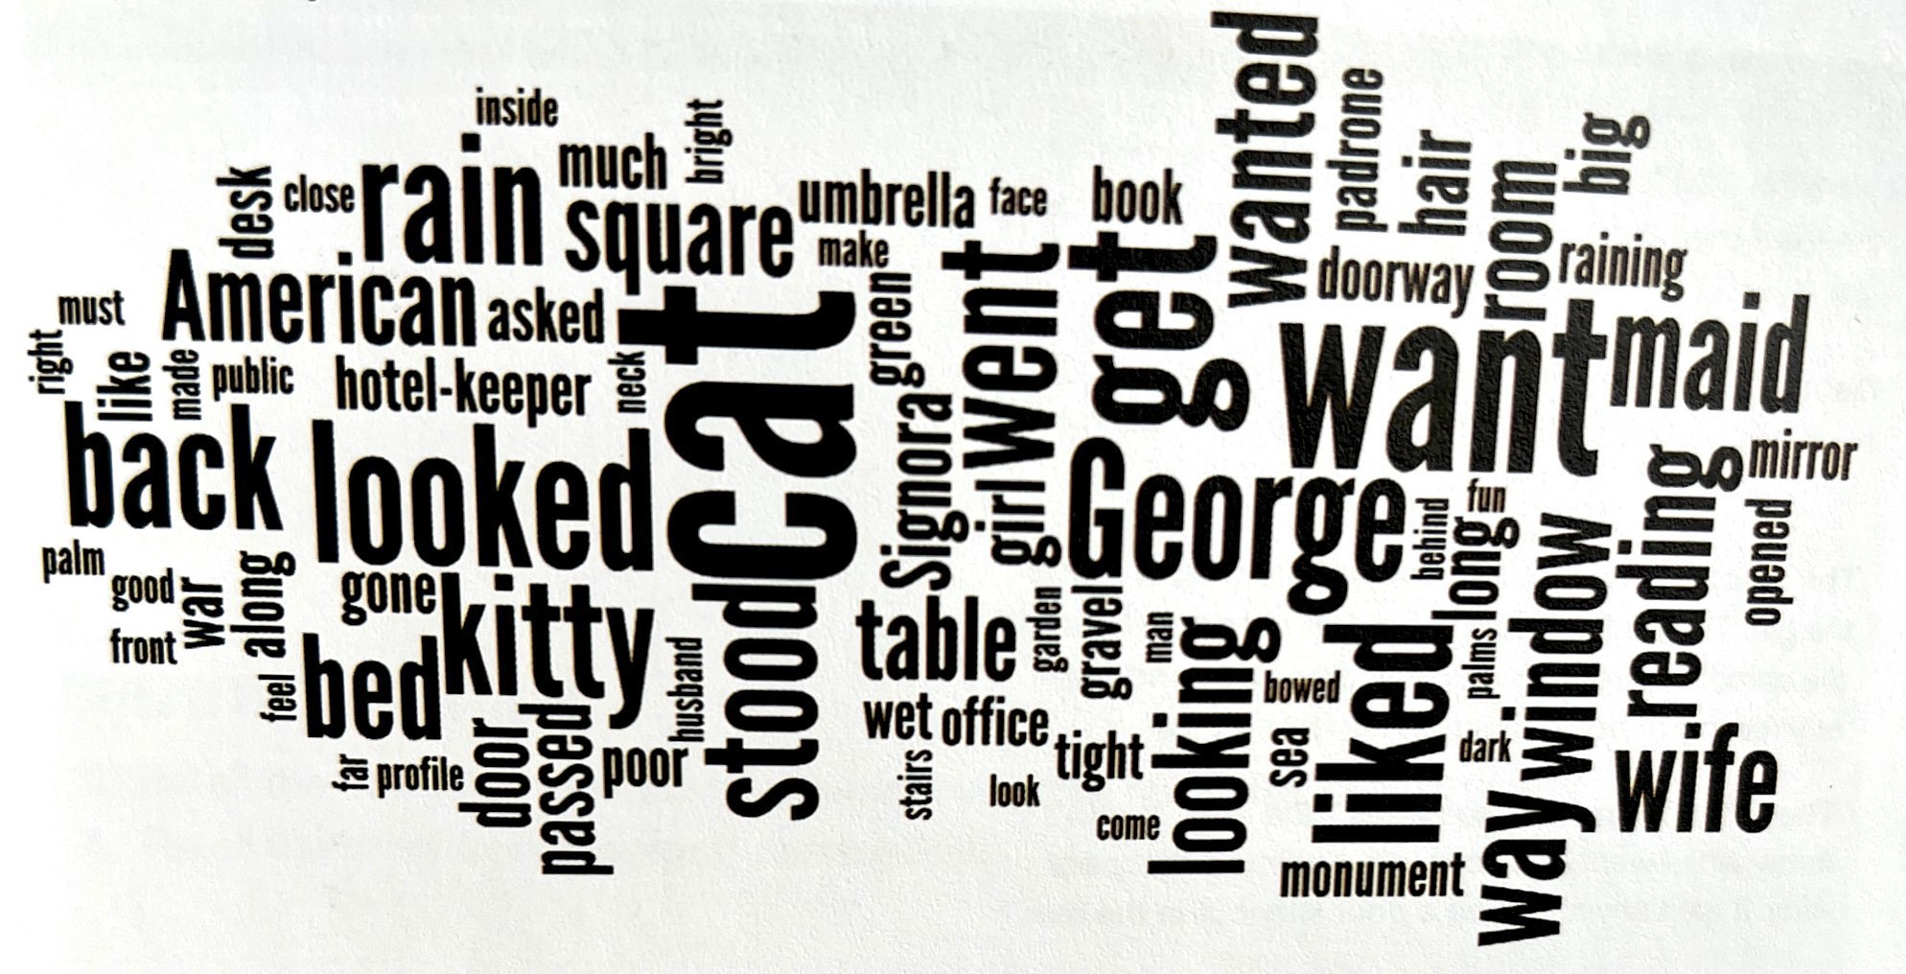

- Setting
Reread the first paragraph and pay attention to: | Example from the text and explain
Setting
Mood/atmosphere
The significance of the weather (in the opening of the story)

- Characterization
A
Read the quotations below and discuss what they reveal about the characters and their relationships
Characterization clue | What it reveals about the character
The wife: She liked the way he wanted to serve her. She liked the way he felt about being a hotel-keeper. She liked his old, heavy face and big hands
George: George looked up and saw the back of her neck, clipped close like a boy’s. “I like it the way it is.”
The wife: Something felt very small and tight inside the girl. The padrone made her feel small and at the same time really important. She had a momentary feeling of being of supreme importance.
The wife: “I wanted it so much, “ she said. “I don’t know why I wanted it so much. I wanted that poor kitty. It isn’t any fun to be a poor kitty out in the rain.”
George: “Oh, shut up and get something to read,” George said. He was reading again.
The wife: His wife was looking out of the window. It was quite dark now and still raining in the palm trees.

B
Which one of the following adjectives characterize George, the wife and the hotel owner:

Helpful – immature – relaxed – responsible – understanding – kind – mindless – touchy – Childish – lonely – bored – selfish – supportive – caring – unreasonable – irritable – irresponsible – thoughtful – loving – superficial – satisfied – depressed – contented – passive unwilling

George | The hotel owner | The wife

C
Why do you think the girl does not have a name? Why is she only referred to as “the American wife” or “the American girl”?

- Symbolism
A symbol is a word, object or thing that is used to represent something else.
Make a list of the symbols in the text and explain their meaning.

Symbol | What it means

- Hemingway’s writing style (The iceberg theory)
A
What is your first impression of Hemingway? How would you characterize his style?

B
In the following two quotations Hemingway describes his writing style, which he refers to as the Iceberg Theory. Explain the Iceberg Theory in your own words.

If it is any use to know it, I always try to write on the principle of the iceberg. There is seven-eighths of it underwater for every part that shows. Anything you know you can eliminate and it only strengthens your iceberg. It is the part that doesn't show. If a writer omits some thing because he does not know it then there is a hole in the story.

If a writer of prose knows enough about what he is writing about he may omit things that will have a feeling of those things as strongly as though the writer had stated them. The dignity of movement of an ice berg is due to only one-eighth of it being above water. A good writer does not need to reveal every detail of a character or action.

The Iceberg Theory in your own words:

C
Discuss how the Iceberg Theory is conveyed in "Cat in the Rain".

- Repetition: Find at least 2 examples of repetition in the text (write the page number and lines)

-
-

- Creative writing

Retell the story from:

A: the perspective of the Italian hotel staff, or
B: George's perspective.

Your text here:

