Written work – The Same Sea (write a paragraph using the PEE-model)

Task: write a paragraph on one of the following topics focusing on The Same Sea by Adran Markle.
- The setting
- Relationship between the man and woman
- Narrator
- Contrasts
- The ending

Your paragraph must include:
- A hook (appetitvækker)
- The title, author/director, and main focus(indledende sætning)
- Use of the PEE-model (pointe, eksempel*, forklaring)
*two references to the text (p. 33 l. 26).
- - must be written in present tense (husk at skrive i NUTID)

A hook | Her stiller du et relevant spørgsmål omhandlende teksten, som kan indfange læserens nysgerrighed eks.  Does upbringing always affect how we raise our children?
Present the title, author(instructor) and theme | Start din paragraph med at fortælle om, hvad teksten/filmens fokus er, samt præsentere teksten forfatter og titel
P (pointe) | Her skriver du din påstand, din pointe, det som du vil kommunikere om teksten.  Eks. The main character is in conflict with himself because he wants to do better than his own father at the same time he wants to protect his son from failing.  Eller: the story I set to take place in…  Eller: The main theme in the story is how..
E (example) | Find et citat eller en henvisning til en bestemt passage, der viser din påstand (underbygger den) og skriv det ind her. Husk at henvise i parentes (se ovenover hvordan). Hvis du citerer, så brug citationstegn med en henvisning lige efter.  For example…  This is shown when..  This becomes clear when..
E (explain) | Forklar hvad det er i dit eksempel, som gør at vi kan se du har ret i din påstand  In this quotation it becomes clear that.. /from this we can infer that

*Eksempel på et ’hook’ og titel/forfatter/tema indledning:
Do young people always make their own decisions about education or profession? Or do they leave it to their parents? Focusing on themes such as expectations and pressure to do well in life from other family members, Nick Weber’s short story ‘Braces’ (2016) describes the relationship between a boy, Nick, his father and his grandfather, who all seem to have different expectations about Nick’s future.

Rød= hooket
Grøn= tema
Blå= forfatter og titel

*Eksempel på brug af PEE-modellen i en paragraph:
PEE: Point (main idea), Evidence, Explain. (kaldes også: topic sentence, supporting sentences and concluding sentence)
(P) Nick is an adolescent who wants to show his father that he can cope with the events taking place in the Indian camp. (E) It becomes clear in the conversation he has with his father in the Indian woman’s shanty. When Nick’s father tells him that the Indian woman is going to have a baby, he replies, “I know” (p. 14, 1.2). (E) This shows that Nick wants to assure his father that he is no longer a child.

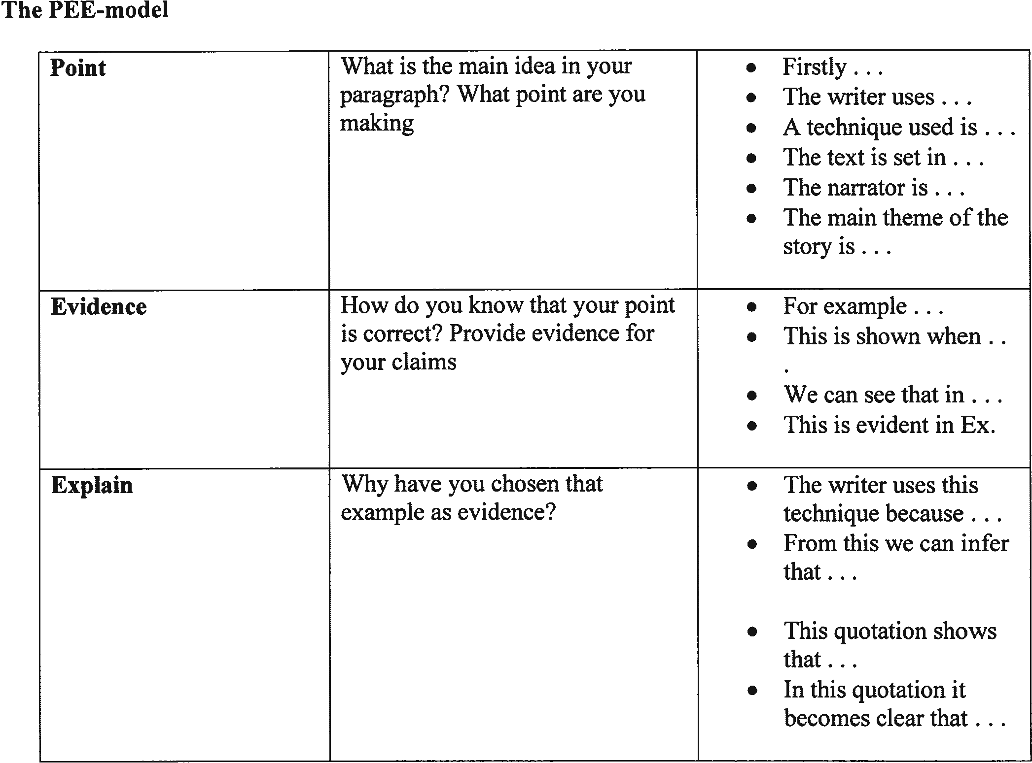

Write your own paragraph here:
Choice of topic:
A hook
An introductory sentence

P (pointe)

E (example)

E (explain)

