The Shawshank Redemption (1994)
While watching:
Characters – choose a character to follow and describe throughout the movie
Andy | Red

Cinematic devices – Pay attention to angles and sound when Andy enters the prison (10:00 - 12:50)
Angle | Example | Effect (after)

Sound | Example | Effect (after)

Institutionalization: how do the characters handle life outside prison?
Brooks Hatlen | Andy | Red

Differences between book and movie?

After watching:

- Character development: how and when does your character develop? Why is that?

- Angles and sound: Decide on angles/sound and EFFECT

Angles
Eye level | The camera is placed at the same level as the characters or objects.
Low angle | The camera is placed below the person or object. This may be used to make characters look powerful and/or arrogant.
High angle | The camera is placed above the person or object. Usually, this gives the viewer a sense of overview of the scene and at the same time makes the characters and objects look small.
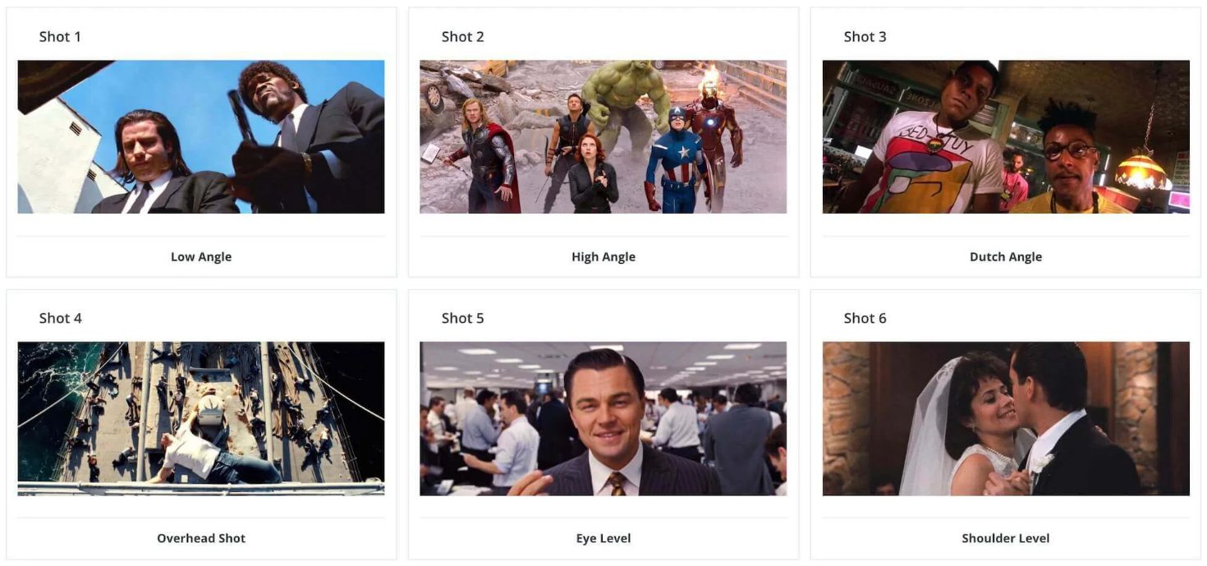

Sound
Diegetic sound | Sound from the world of the film.
Non-diegetic sound | Sound from outside the world of the film.
Contrapuntal sound | Sound that is contrast to what is going on (e.g. happy music and a murder).
Sound effects | Non-diegetic sound effects other than music and dialogue.
Music | Non-diegetic music added to create atmosphere.
Voice-over/narration | Words spoken by somebody off-screen.
Silence | No sound.

- Differences between book and movie? What’s different and why do you think it has been made this way?

- The prison formula – characters. Do any of the characters fit into the prison-formula?
The fixer (the one who can get it for you)
The mentor (old timer, institutionalized)
The corrupt warden
The shower bandit
The new fish (the brain)
The cell-buddy (best friend)

- Themes (what are the main themes?)

- Message (is there a message – budskab)?

