Læsespørgsmål til artikel:
Hvornår levede Kollwitz cirka?
Hvilken samtid levede hun i?
Hvad lavede hendes mand? Hvad lavede Kollwitz til daglig?
Hvis man inddeler hendes kunstvirke i første og anden halvdel, hvad handler disse så om?
Hvilken form for kunst laver Kollwitz?
Hvilke temaer arbejder hun ofte med?

Arbejde med værker- vælg mindst 2:
1, fakta. Hvad ser vi/ beskrivelse. Årstal, materiale, størrelsesforhold.
2, indhold/betydning. Samtid- hvad sker der? Hvad vil kunstneren sige med sit værk? Hvorfor laver han/hun det?

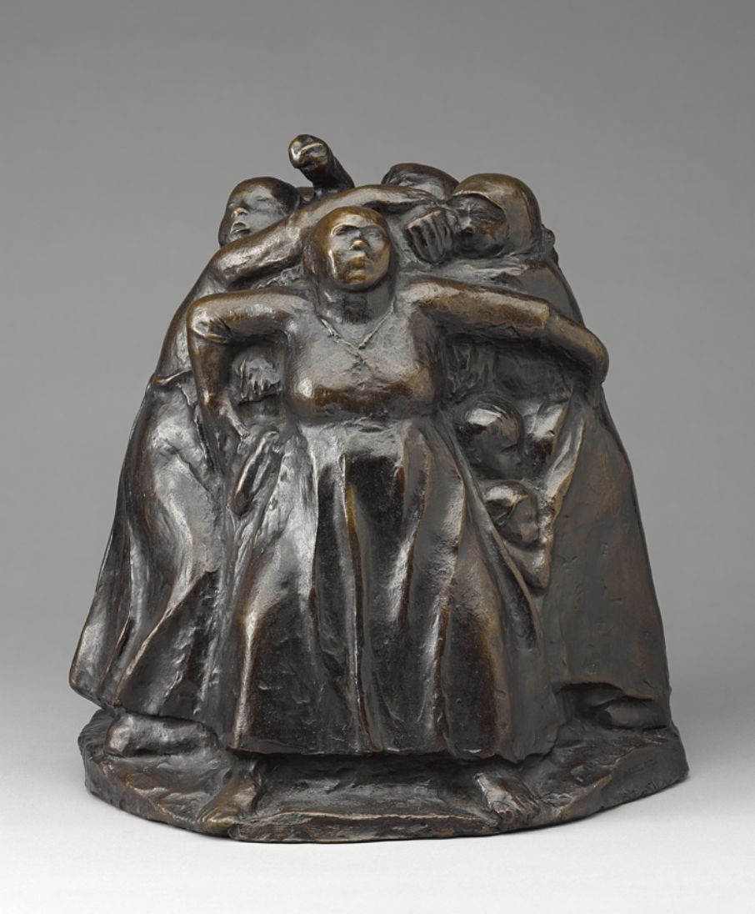
Käthe Kollwitz (German, 1867–1945), Turm der Mütter (Tower of Mothers), 1937–38. Bronze, 27.9 × 27.4 × 28.8 cm. Art Gallery of Ontario, Toronto.
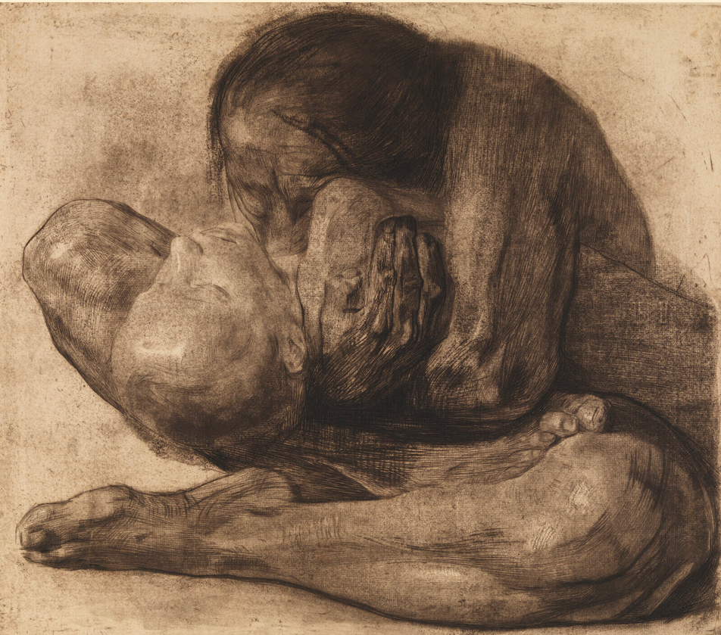
Käthe Kollwitz, Kvinde med dødt barn, 1903, Radering, koldnål, blødgrund og fladbidning, trykt i brunt
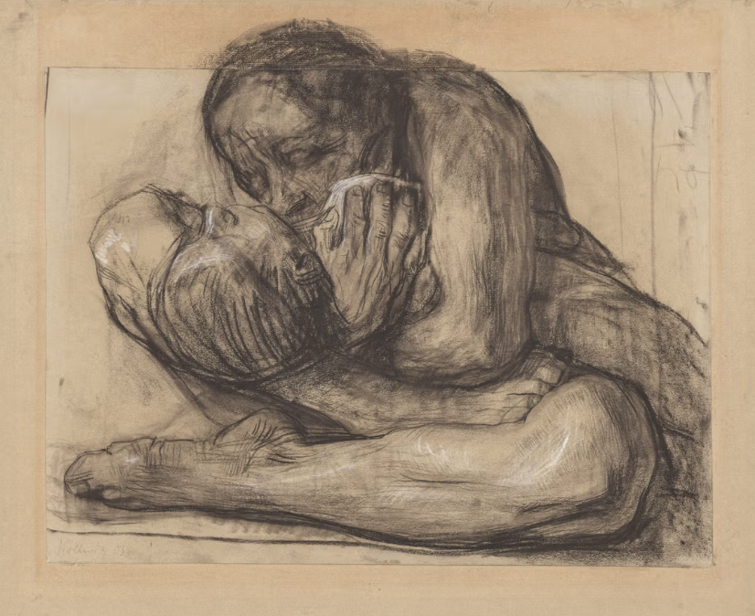
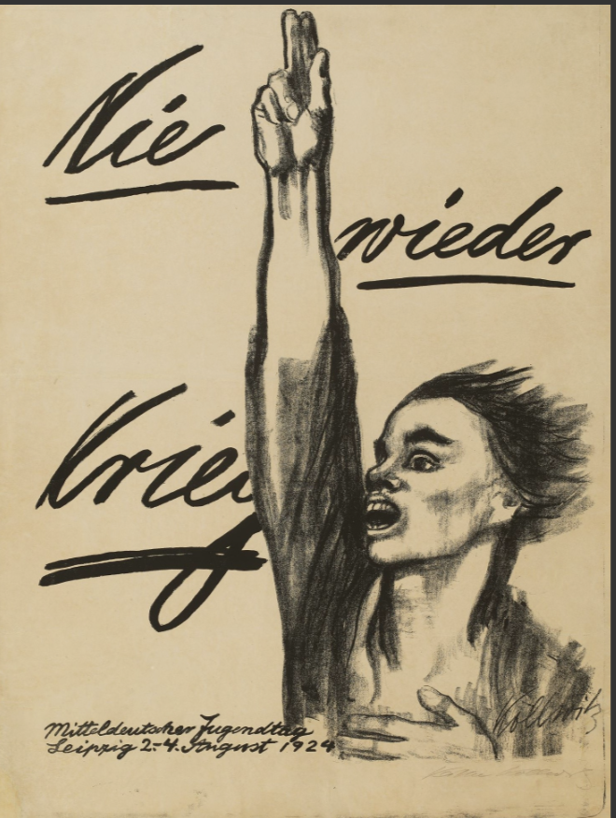
”Aldrig mere krig”, plakat, 1942, kridt- og pensellitografi

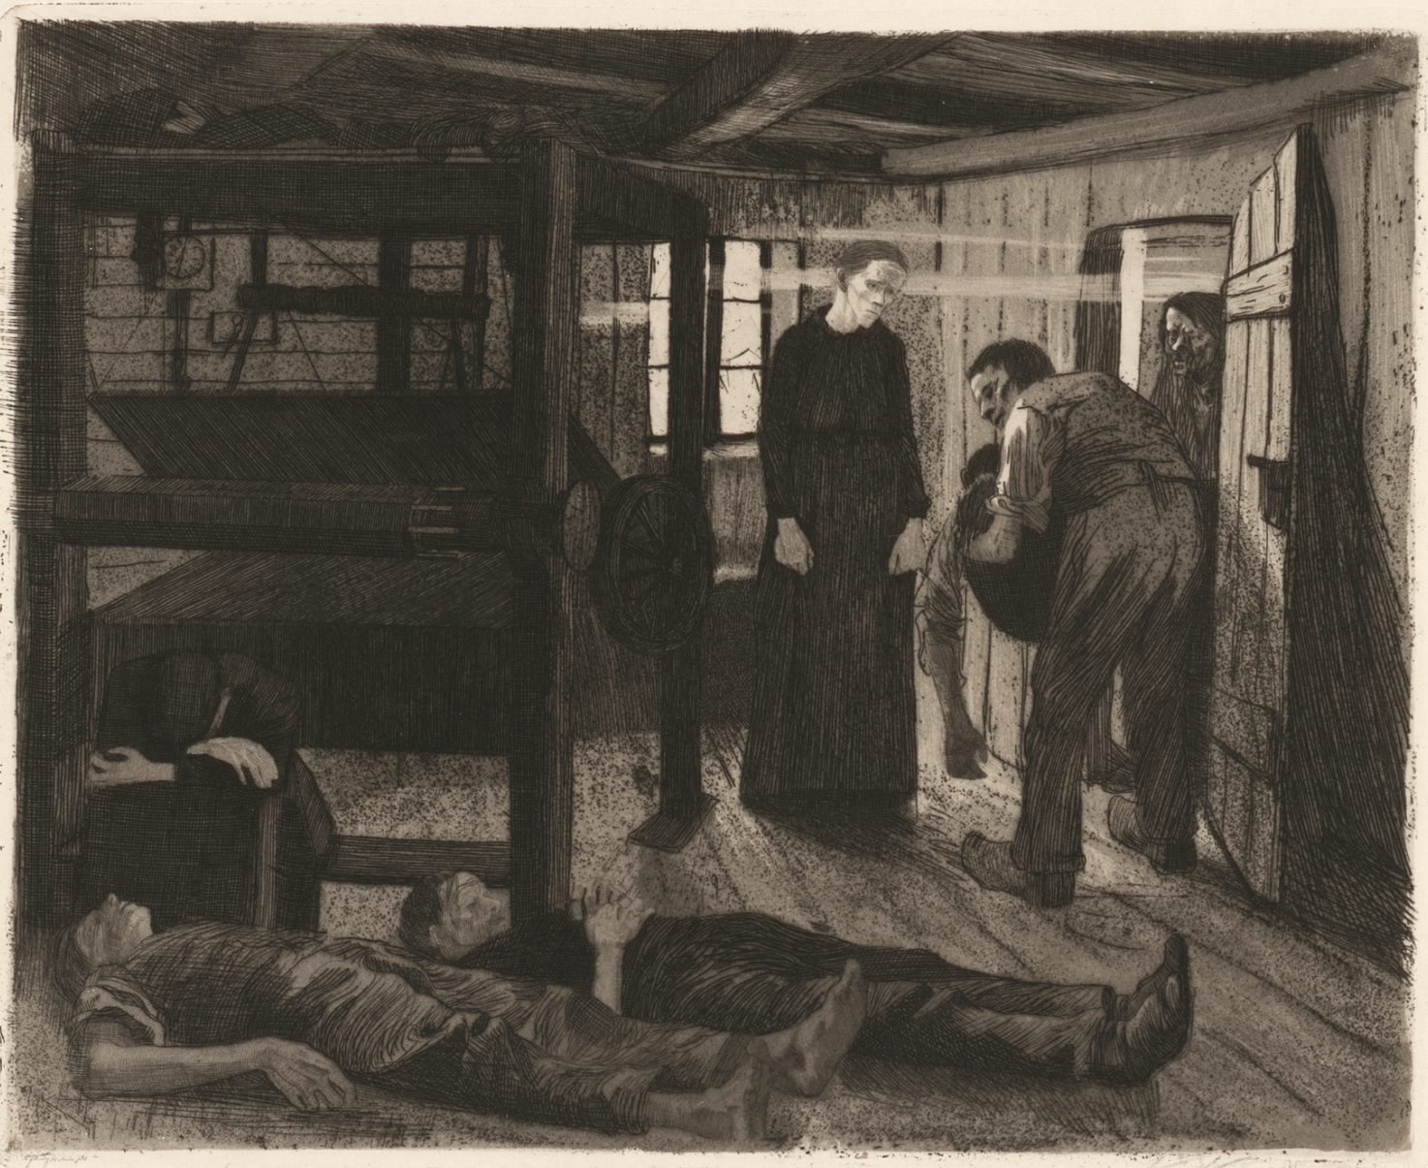
”Væveroprør”, 1893-1897, aquatint

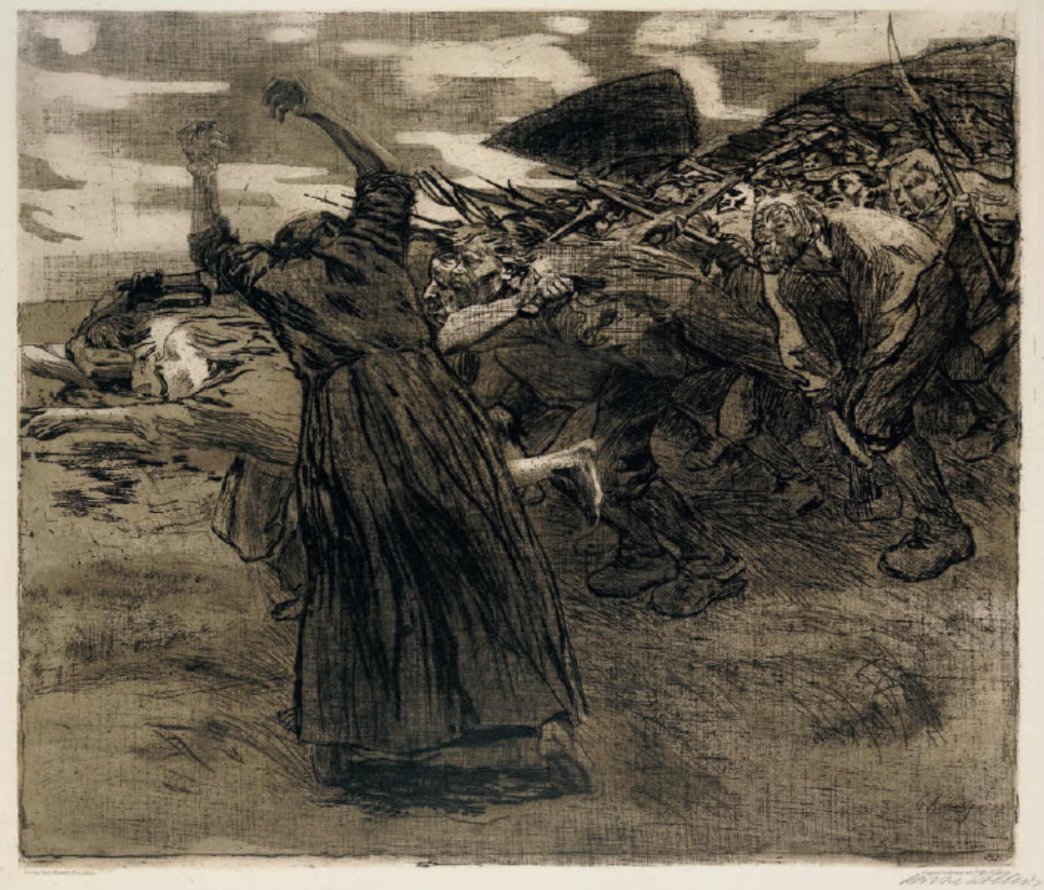

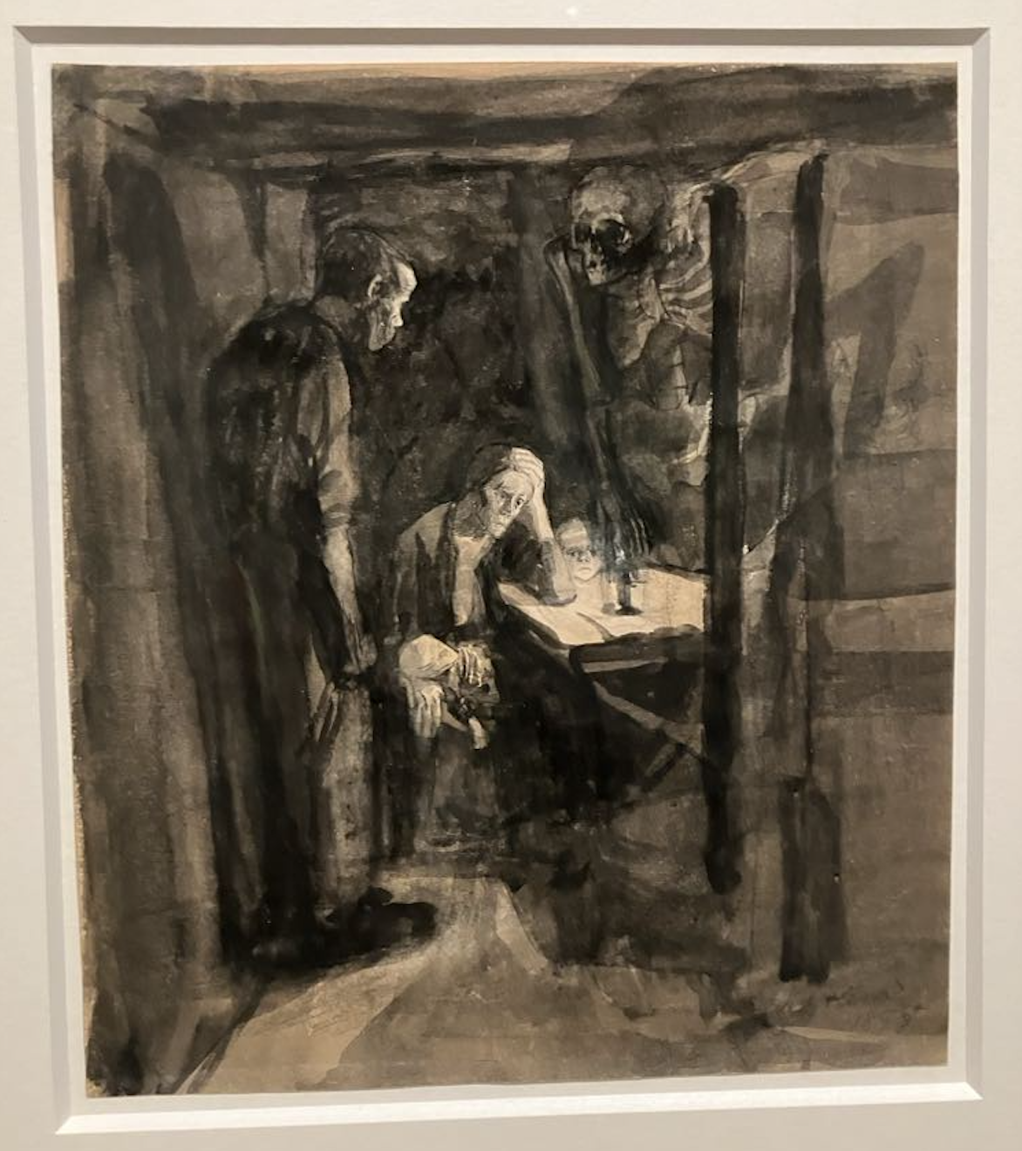
”Død- forstudier til blad 2”, 1897, blæk og pastel

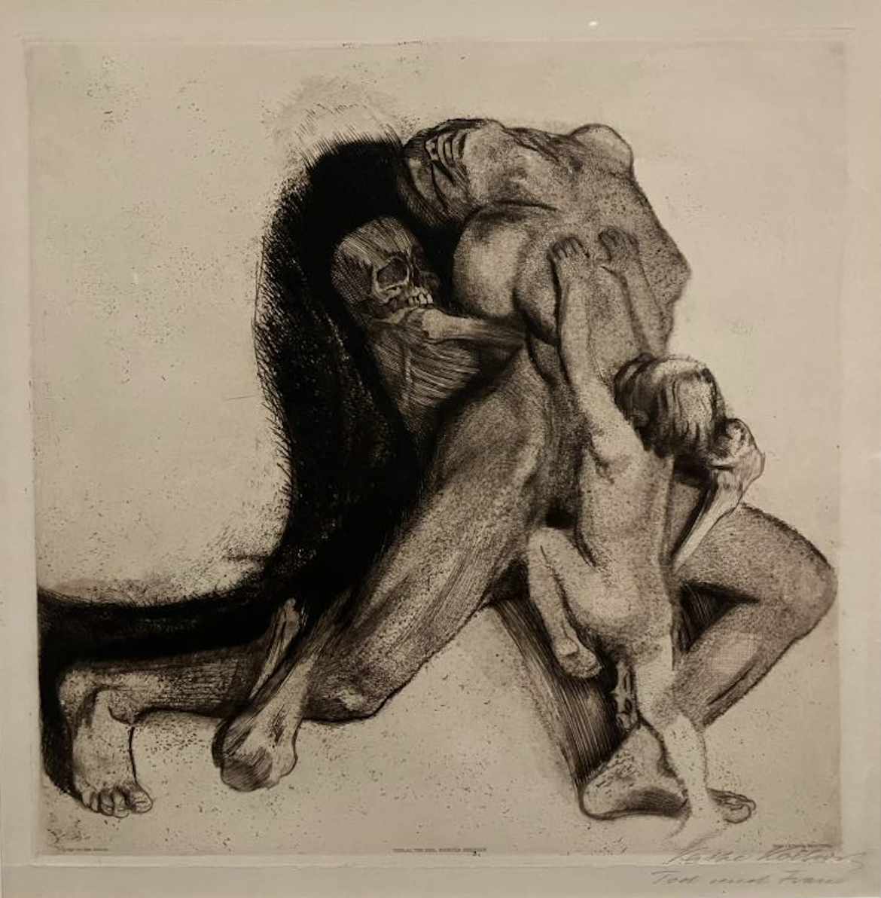
”Døden og kvinde”, 1910,

Käthe Kollwitz presented her first series “A Weaver’s Revolt” at the Great Berlin Art Exhibition in 1898, it became her artistic breakthrough. The cycle was inspired by Gerhart Hauptmann’s play “The Weavers”. After “A Weaver’s Revolt”, her second series of prints, entitled “Peasant War”, appeared in 1908. The most important plate, entitled “Outbreak”, was completed in 1903; the Verbindung für historische Kunst (Association for Historical Art) commissioned her to do the new series as a gift for their members. Once again, Käthe Kollwitz chose a revolutionary uprising that had been violently suppressed – this time the peasants revolts in Germany of 1523-26.
The consequences of World War I were still felt strongly in 1920. Käthe Kollwitz lost her younger son Peter during the war, he volunteered for the military service in 1914 and died in Belgium. She artistically processes her grief and guilt in the cycle “War” and executed the series in 1921/22 by using a woodcut technique that was new to her at that time.
Käthe Kollwitz actually dealt with the subject of death throughout her entire artistic work, in her late work the subject seems almost predominant. In the mid-1930s, she implemented a long-term project graphically: the litho series “Death”. In eight lithographs, she shows death in its full range. Käthe Kollwitz closed the episode in 1937 with the eighth sheet “The Call of Death” and gave the life-marked female figure her own face.

