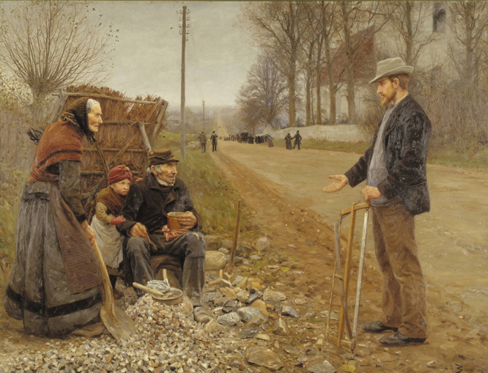
”En landevej”, Brendekilde, 1893, olie, 200x260

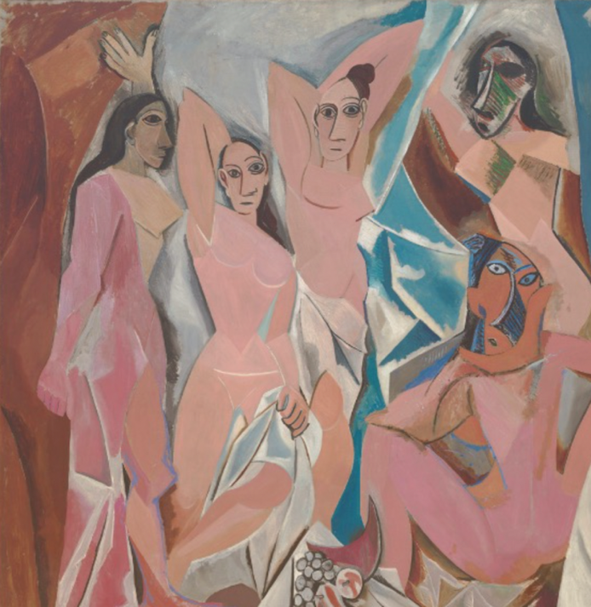
Picasso, “Les Demoiselles d'Avignon”, 1907. Olie, 240x 230

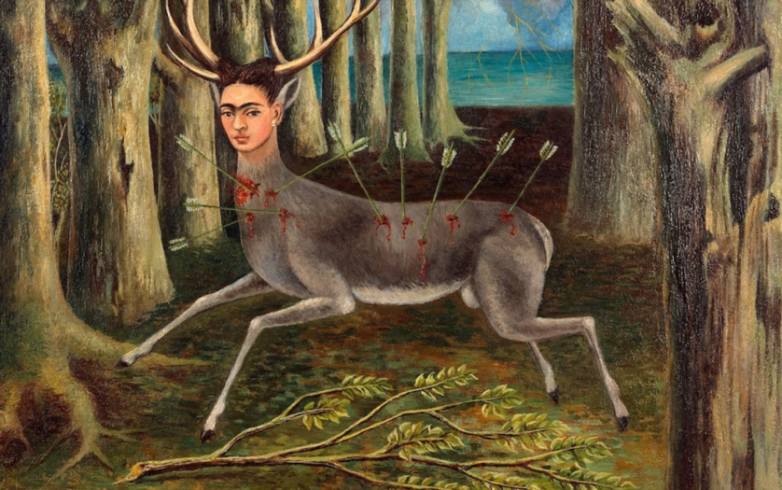
Frida Kahlo,” The wounded deer”, 1946
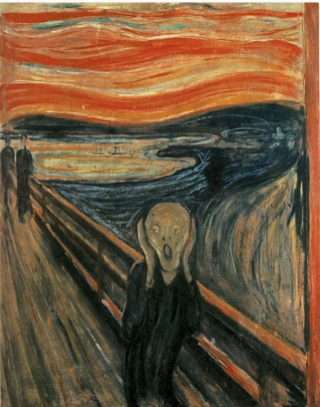
Edvard Munch, “Skriget”, 1893

