Fiction
Examples: novel or short story

- Genre
Is it a short story or a novel?

- Plot/structure
Chronological/flashbacks/in medias res etc.

- Setting
The setting is a description of where and when the story takes place. A setting can be:
- Historical time, season, time of the day etc.
- Nation, country, city, in the countryside, ocean, forest, mountains.
- Environment influenced by social class, age group, ethnic group.
- Fantasy or realistic environment.

Is the setting an important plot or theme?

- Narrator/Point of View (PoV)
The two most common types of narrator/POV are first person narrator and third person narrator:
Type of narrator/Pov | Characteristics
First person narrator | - is an I speaker and events are told through the eyes of the I (subjective).  - only allows the reader to know what the I knows.  - can be a character in the story.  - can be a less important character witnessing event  - can be a character re-telling a story he/she was told by someone else.  - gives a closeness to the character.  - makes it easier for the reader to identify with the character
Third person narrator | - can be a character in the story.  - is an observer outside the action.  - is referred to as he/she.  - makes it harder for the reader to identify with the characters.  - allows the reader to know the thoughts of all characters or one character.

3.1 Omniscient, limited omniscient, objective narrator
 | First person narrator | Third person narrator
Omniscient | NO - a first person narrator cannot be omniscient because it is restricted to what the I narrator knows. | YES - can be omniscient and know what everyone thinks and the author may make hisIher own comments.
Limited omniscient | NO - a first person narrator cannot be limited omniscient because it is restricted to what the I narrator knows. | YES - the story can be told by a focalized third person narrator - e.g. events are told through the eyes of a specific character who only knows how he/she sees the world
Objective | NO - sees the world from the perspective of the I narrator. | NO - sees the world from the perspective of the I narrator.
Subjective | YES - is subjective because it is seen through the eyes of the I narrator. | YES - is subjective because it is seen through the eyes of the I narrator.
In some stories if can also be relevant to comment on whether the author is reliable or unreliable.

- Characterization
Characterization deals with how the characters in the story are described and develop. A main character in a text is called a protagonist.
Characteristics | What to look for
External characteristics | - gender  - age  - appearance  - occupation
Internal characteristics | What feelings are dominant?  - anxiety  - bitterness - is the character in conflict with one self?  - happiness  - sorrow  - confusion etc.  Does the character's past affect him/her?  How does the character behave throughout the text?  Do his/her actions change throughout the story?
Personal characteristics | - patient  - bad-tempered  - shy  - emotional  - dominant  - naive  - snobbish  - lazy etc.
Social characteristics | - education  - job  - position in the family  - relationship to other people
Values important to the character | - material possessions  - freedom  - excitement  - challenge  - respect  - order
Static or dynamic | Static:  A static character remains the same throughout the story. Characters with an already existing charismatic, appealing or heroic persona tend NOT to change.  Dynamic:  A dynamic character develops through the story and it is what makes the story compelling. Dynamic characters may go through life-changing events, come of age, go through difficult trials or develop new qualities for better or worse.

Other character types:
Flat character = no depth, no change
Round character = complex character, is not necessarily dynamic
Stock character = stereotypical characters such as a cowboy
Protagonist = the main character of the story
Antagonist = represent the opposite of the protagonist

- Style and language
Images, metaphors, symbols?

- Themes
A theme is the underlying topic or the universal idea which the author wants to pass on to the reader through the literary text. . It can be about universal ideas, general human conditions such as love, hate and relationships or about conditions concerning specific groups such as immigrants, children or cultures. Maybe the theme is shown through contrasts or the conflict.
- Message
In other words, the writer has something he or she wants to tell or teach the readers. Here you cold also include the title (or in “theme”).

- Author
Do I know anything about this author? Have I read them before?

Non-fiction
Examples: Speech, article

The rhetorical pentagram
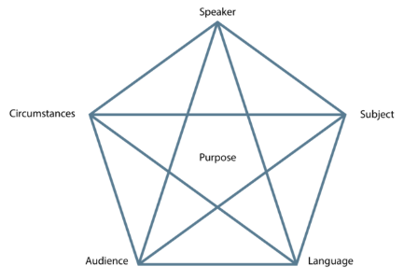
Purpose = intention

- The Rhetorical Pentagram
  - Sender/speaker
Who is the sender of the non-fiction text? What do you know about the sender?
- Occupation
- Education
- Qualifications
- Background
- Political interests etc.

  - Message/Subject
Which message/idea is sent to the receiver? When was it sent and where? Find the main arguments put forward by the sender and use Toulmin’s model of argumentation
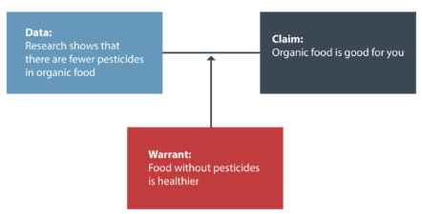v
Claim: The most simple form of an argument is a claim. The statement to be argued.
Data: The evidence
Warrant: Supports and substantiates your data
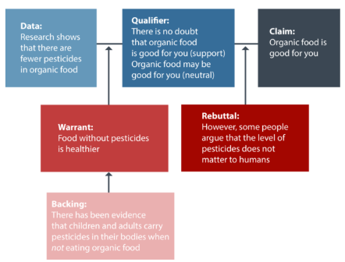

Backing: Additional data or information to back the warrant.
Qualifiers: Used to express the relative strengths of warrants
Rebuttal: A rebuttal acknowledges that the argument has limitation

Modes of appeal/persuasion
Logos: Reasoning, facts, statistics, data
Ethos: Expertise, credibility, authority - personal or from others (the sponsorship effect)
Pathos: Emotion

Remember to explain how it appeals to ____

  - Channel/circumstances
Which channel is used? Is it a newspaper and, if so, which? Which type of article is it? Is it a magazine? Is it a blog? Is it a company website? Where is the speech being held? when?

  - Receiver/Audience
Who is the intended receiver? What is their Social group? Education? Age group etc.

  - Language
Is the language complicated or simple? Formal or informal? Does the language correspond with the topic? What word-classes are dominant and what is the effect of having a certain dominant word-class? What kind of words are these?

Rhetorical devices
- METAPHORS = A word or expression is used in a transferred or figurative sense. A metaphor is based on a relationship between two elements, and the metaphor replaces one element with the other
“the autumn of life”
o DEAD METAPHORS = the metaphor no longer creates any new meaning
“table leg”
o LITERARY METAPHORS = the metaphor creates new meaning that extends beyond the two elements involved.
“life is a highway”
- SIMILE = When two concepts, things, or feelings are compared explicitly (as opposed to the metaphor, where the comparison is implicit). This could be indicated by the word “like” or “as”.
“Pretty like a rose”
- METONOMY = When something associated with an object or idea stands in for the idea itself.
“the White House has issued a statement”
o SYNECDOCHE = A form of metonymy in which one part of an object or idea stands in for the while of that object or idea.
“Ask for her hand”
- PUN = When a word is understood in at least two different ways at once.
“A Cross-eyed teacher could not control his pupils”
- CONCEIT = When a metaphor is extended and explored so that it becomes the governing idea of a poem.
In this poem, two lovers are being compared to a compass.
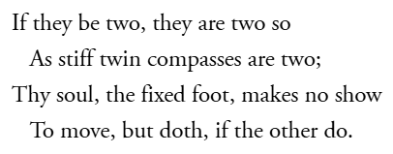
- PERSONIFICATION = When an abstract concept or inanimate object is given human attributes.
“The wind whispered secrets through the trees”
- APOSTROPHE = A ‘vocalized’ address within a poem directed at an inanimate object, abstract concept, or an absent figure.
“You! Reading this”
- ALLEGORY = An extended metaphor in which events and actions within a narrative imply a separate series of events and actions ‘outside’ the poem.
The story of the Tortoise of the Hare represents the bigger idea, that being slow and steady wins over being fast and not thorough
Schemes
- ANAPHORA = repeating words at the beginning of successive phrases or clauses.
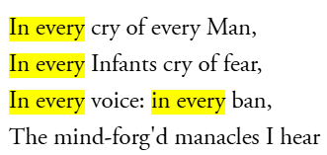
- ANATROPHE = The jumbling of parts of a sentence or phrase.
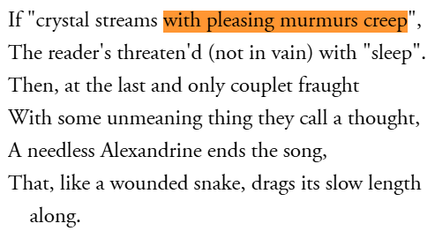
- EPISTROPE = the repetition of words at the end of successive phrases or clauses.
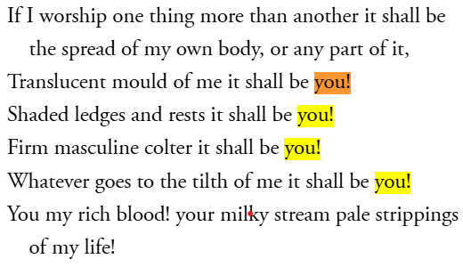
- CHIASMUS = Two successive phrases or clauses switched around to create a cross shape.
“Ask not what your country (A) can do for you (B)
ask what you (B) can do for your country (A)”
- ZEUGMA = When one word refers in the same way to two or more other words in a phrase.
“You held your breath and the door for me."
- SYLLEPSIS = a zeugma in which the governing word applied differently to each of the referent words
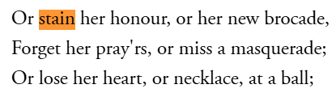
- ANTITHESIS = Juxtaposes contrasting ideas in a balanced structure
"To err is human, to forgive divine"

- ONOMATOPEIA = words that mimic sounds
"buzz”
- ALLUSION = A brief reference to a well-known person, place, thing, or idea
“Achilles heel”
- REPETITION = Repeating words or phrases for emphasis
(Look at ‘Anaphora’)
- ALLITERATION = Repetition of the same initial consonant sound in nearby words
"Peter Piper picked..."
- EUPHEMISMS = An indirect word or phrase that people use to refer to something embarrassing or unpleasant
Die → “pass away”
- RHETORICAL QUESTION = questions that are asked but are not meant to be answered
“Is living in a world of toxins bad?”

- LIST OF THREE = groups of three words, phrases, or ideas to make content more memorable, authoritative, and engaging
“"Of the people, by the people, for the people”

Remember to explain the effect of the device. Fx.
“by stating a rhetorical question he makes sure that the listener engage with the speech, by having them implicitly answer the question

- Non-verbal communication
If you see video-footage, you will notice that the speaker also uses non-verbal language. You can comment on:
- Facial expressions
- Gestures
- Body language and posture
- Appearance
- Setting

