List of contents

1.What is a poem? 2
1.1 Prosody - rhythm 3
2. List of Different Types of Poems 4
2.1 Didactic poems 4
2.2 Dramatic monologue poems 4
2.3 Elegy 4
2.4 Epic poems 4
2.5 Epigrams 4
2.6 Prose poems 4
2.7 Limericks 5
2.8 Slam poetry 5
2.9 Sonnets 5
3. How to analyze a poem (F-L-I-R-T) 7
3.1 Form 7
3.2 Language 8
3.3 Imagery and other rhetorical devices 9
3.4 Rhyme 12
3.5 Theme 14

Poetry tool kit

1.What is a poem?
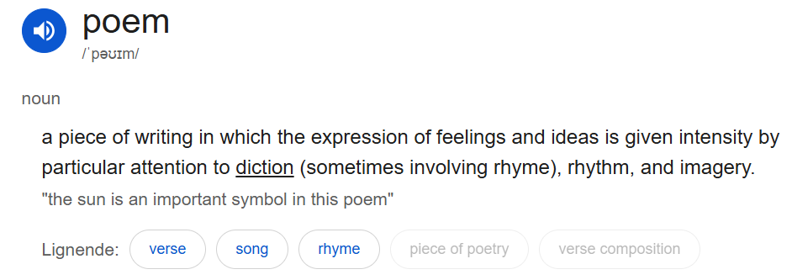
A poem consists of lines (= the lines that are separated by being on top of each other). A bundle of lines makes up a stanza (= multiple lines in one verse).
Poem stanzas
Octave |  | = eight-lines group
Septet |  | = seven-lined group
Sestet |  | = six-lined group
Quintain |  | = five-lines group
Quatrain |  | = four-lined group
Tercet |  | = three-lined group
Couplet |  | = two-lined group
Monostich |  | = one line

1.1 Prosody - rhythm
When analyzing and reading a poem you look at how the syllables are stressed. We also look at feet (= A foot (or poetic foot) is the basic unit of measurement in poetry, consisting of a specific combination of stressed “ \ “ and unstressed “ – “ syllables). The stresses and feet help create the metre (= the regular rhythmic pattern seen and heard in verse). There are three types of English metre:
- Syllabic (or quantitative) metre: counts syllables only

Fx.:
“Sep | tem | ber | rain | falls | on | the | house”
- Accentual (or alliterative) metre: counts stresses only (mostly four stresses)

Fx.:
“Grendel groped for the grim-hearted warriors”
- Accentual-syllabic metre: counts both syllables and stresses

Fx.:
“shall I | compare | thee to | a sum | mer’s day”

(If there is no regular rhythm, the poem is said to be written in free verse)

The stress pattern can also differ between falling metre (= lines containg feet that end on an unstressed syllable) or rising metre (= lines containing feet that end on a stressed syllable).

Falling metre: | Rising metre:
“By the shore of gitche gumee, | “to be or not to be”

2. List of Different Types of Poems

2.1 Didactic poems
Poems with a clear message or moral. Didactic poems want to teach or explain something - a moral, a truth or maybe a principle. This type of poem is therefore very straightforward in order for the reader to understand the message.

2.2 Dramatic monologue poems
Poems where an imagined speaker addresses a silent listener. This listener is usually not the reader of the poem. It is also known as a persona poem because the poet speaks through a fictional character.

2.3 Elegy
An elegy is an ancient Greek form of poem which expresses sorrow for someone who is dead. A traditional elegy expresses three stages of loss: first, lament (=klagesang), where sorrow and grief are expressed; second, praise and admiration for the dead are expressed and finally, consolation and solace.

2.4 Epic poems
Long narrative poems with a heroic protagonist. The poem describes the hero's mythical or historical importance. Therefore, elements such as legendary adventures and superhuman deeds are included. Some of the oldest narratives such as Homer's Iliad and Odyssey are in epic form. Over time, epic poetry has evolved and therefore taken a slightly different form.

2.5 Epigrams
Very short poems which are often witty or satirical. The subject of an epigram is usually a single thought or event. Epigrams became popular in the 16th and 17th century England due to poets such as Lord Byron, John Donne and Samuel T. Coleridge. Newer poets include Oscar Wilde and William Butler Yeats.

2.6 Prose poems
A prose poem is read like a poem but is in the form of prose. Prose poems do not have the same line breaks as traditional rhyming poems but make use of other literary techniques such as repetition, symbols and metaphors.

2.7 Limericks
Limericks are funny and light-hearted poems which are also often used as nursery rhymes. They have a five-line structure with end rhymes structured as aabba. Limericks are often funny, nonsensical or maybe vulgar in their message.

2.8 Slam poetry
Slam poetry combines writing competitions with live performance and audience participation. It is performed at events called poetry slams.

2.9 Sonnets
A sonnet is a poem of one stanza (=strofe) with fourteen lines. It is written in what is called iambic pentameter. An iamb is a two-syllable foot (the first unstressed and the second stressed) and an iambic pentameter is a ten syllable line (five two-syllable iambs) with unstressed and stressed syllables. When saying the rhythm of the iambic pentameter aloud, it sounds like a heartbeat:
baBOOM / baBOOM / baBOOM / baBOOM / baBOOM
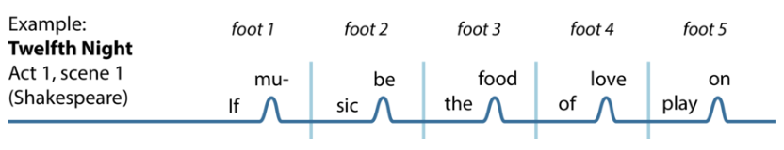

2.9.1 The Petrarchan/Italian Sonnet
The Italian or the Petrarchan sonnet (named after the Italian poet Petrarch) is divided into two stanzas (8 lines) and an answering sestet (the remaining 6 lines).
The rhyme scheme goes: abba abba cdecde or cdccdc.

2.9.2 The Shakespearean/English sonnet
The Shakespearean or English sonnet has a different structure and rhyme scheme. The first twelve lines are divided into three parts called quatrains because they are composed of four lines each. The purpose of the quatrains is for the poet to establish the theme or problem which is then solved in the last two lines called the couplet.
The rhyme of the Shakespearean sonnet goes: abab cdcd efef gg.
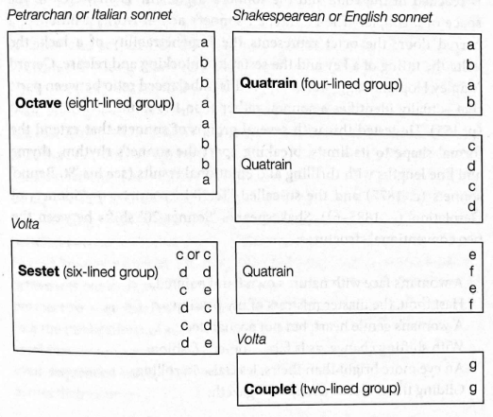
Volta (= A volta is the "turn" in a sonnet, representing a dramatic shift in thought, argument, tone, or emotion. Usually occurring between the octave and sestet (line 9) in Italian sonnets or before the final couplet (line 13) in Shakespearean sonnets, it functions as a fulcrum, pivoting the poem toward a resolution or new perspective)

Sonnet stanzas

Octave |  | = eight-lined group
Sestet |  | = six-lined group
Quatrain |  | = four-lined group
Couplet |  | = two-lined group
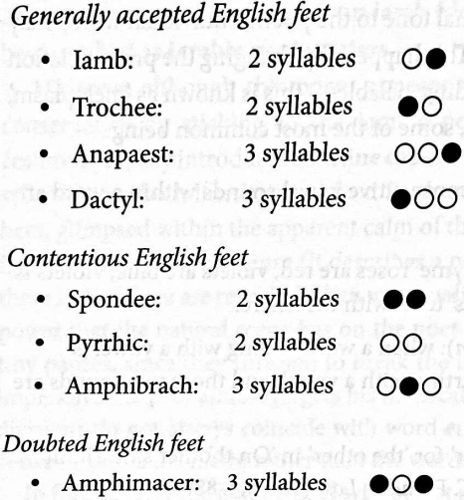

3. How to analyze a poem (F-L-I-R-T)

3.1 Form
When you analyse the structure of a poem, you should look at a combination of different elements. First, take a look at the poem and consider how it is presented. You can ask yourself the following questions:
- How is it structured? (number of lines and stanzas, long or short lines, run-on lines)
- Does it have a graphic pattern, maybe in the form of shapes that add meaning to the poem? This is called a concrete/pattern poem. Some concrete poems make no sense. It is the shape that gives meaning to the poem. Does it have a pattern where typography or lines are arranged in an unusual way, often to extend or convey the emotional content of the words? This is called figure poetry.
- Does the punctuation in the poem differ from normal punctuation? (no punctuation at all, use of capital letters, marked words, use of italics, question marks etc.).

Fx.:

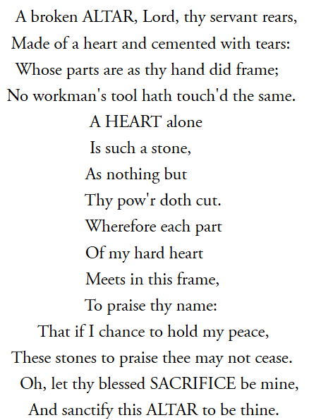 |  | 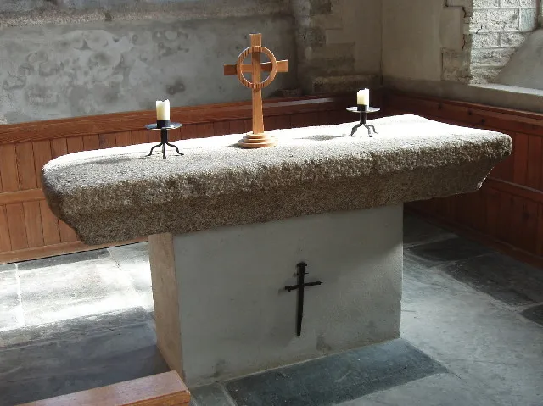

When describing the lines of the poem, you can describe how the lines follow each other:
- End-stopped lined: lines in which the sense of a phrase fits with its line length; lines will often feature punctuation at their ends to emphasize this.

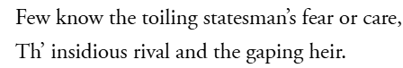

- Enjambment: when the syntax of a phrase carries over across a line break.
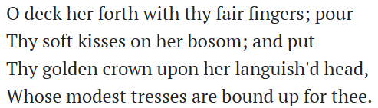
- Caesura: a pause of a break occurring within a metrical line, usually to suggest a natural speech pattern.
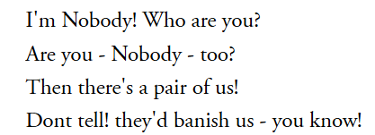

3.2 Language
Besides looking at structure, you should also include the use of language in your analysis of the poem. You may want to look at:
- Sentence structure (the use of long/short, correct sentence structure or unusual sentence structure)
- Choice of words (well-known, rare or self-fabricated words, slang, everyday language, use of sound words etc.)
- Word classes and whether some are used more than others and why (use of adjectives, verbs, nouns etc.)
- Style (formal or informal style, stream of consciousness)

Word use
If you want to do a more in-depth poetry analysis, you can dig even deeper into the use of language by asking yourself these questions:
  - Does the poem express certain semantic fields and why?
  - What type of nouns are used - concrete or abstract or other - and what is the effect of this?
  - What type of verbs are used and to what effect?
    - sensory (e.g. taste, smell, feel)
    - action (e.g. run, swim, listen, believe)
    - stative (e.g. love, hate, need, have)
    - linking (e.g. be, seem, appear, become)
    - helping (e.g. do, be, can, will)
  - What is the tone of the poem and how can you tell? (everyday, naive, serious, fun, playful, humorous, sad, passionate, mournful, indignant, elated, sentimental etc.)

3.3 Imagery and other rhetorical devices
In poems rhetorical devices and imagery can appear. It’s important to describe the effect of these. Examples of these include:
Tropes:
- METAPHORS = A word or expression is used in a transferred or figurative sense. A metaphor is based on a relationship between two elements, and the metaphor replaces one element with the other
“the autumn of life”
  - DEAD METAPHORS = the metaphor no longer creates any new meaning
“table leg”

  - LITERARY METAPHORS = the metaphor creates new meaning that extends beyond the two elements involved

“life is a highway”
- SIMILE = When two concepts, things, or feelings are compared explicitly (as opposed to the metaphor, where the comparison is implicit). This could be indicated by the word “like” or “as”.
“Pretty like a rose”
- METONOMY = When something associated with an object or idea stands in for the idea itself.
“the White House has issued a statement”
  - SYNECDOCHE = A form of metonymy in which one part of an object or idea stands in for the while of that object or idea.

“Ask for her hand”
- PUN = When a word is understood in at least two different ways at once.

“A Cross-eyed teacher could not control his pupils”
- CONCEIT = When a metaphor is extended and explored so that it becomes the governing idea of a poem.

In this poem, two lovers are being compared to a compass.

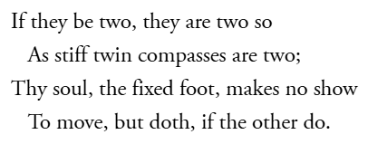

- PERSONIFICATION = When an abstract concept or inanimate object is given human attributes.
“The wind whispered secrets through the trees”

- APOSTROPHE = A ‘vocalized’ address within a poem directed at an inanimate object, abstract concept, or an absent figure.
“You! Reading this”
- ALLEGORY = An extended metaphor in which events and actions within a narrative imply a separate series of events and actions ‘outside’ the poem.

The story of the Tortoise of the Hare represents the bigger idea, that being slow and steady wins over being fast and not thorough

Schemes:
- ANAPHORA = repeating words at the beginning of successive phrases or clauses.

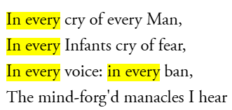

- ANATROPHE = The jumbling of parts of a sentence or phrase.
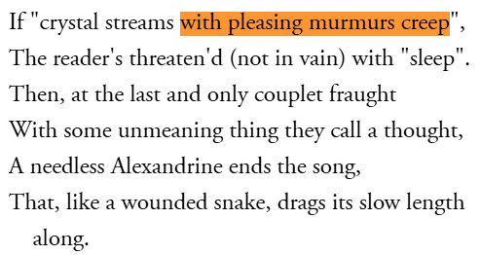
- EPISTROPE = the repetition of words at the end of successive phrases or clauses.

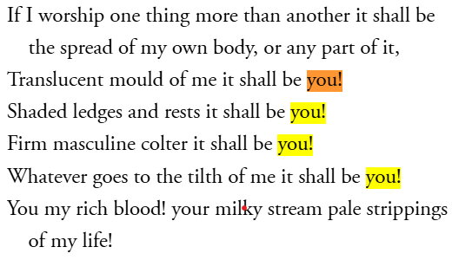

- CHIASMUS = Two successive phrases or clauses switched around to create a cross shape.

“Ask not what your country (A) can do for you (B)
ask what you (B) can do for your country (A)”

- ZEUGMA = When one word refers in the same way to two or more other words in a phrase.
“You held your breath and the door for me."
- SYLLEPSIS = a zeugma in which the governing word applied differently to each of the referent words.
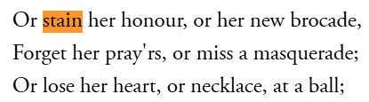
- ANTITHESIS = Juxtaposes contrasting ideas in a balanced structure
"To err is human, to forgive divine"

- ONOMATOPEIA = words that mimic sounds
"buzz”
- ALLUSION = A brief reference to a well-known person, place, thing, or idea
“Achilles heel”
- REPETITION = Repeating words or phrases for emphasis

(Look at ‘Anaphora’)
- ALLITERATION = Repetition of the same initial consonant sound in nearby words
"Peter Piper picked..."
- EUPHEMISMS = An indirect word or phrase that people use to refer to something embarrassing or unpleasant
Die “pass away”

3.4 Rhyme
Does the poem rhyme? You can indicate rhyme by giving the word a letter: a, b, c, d or more. An example could be:
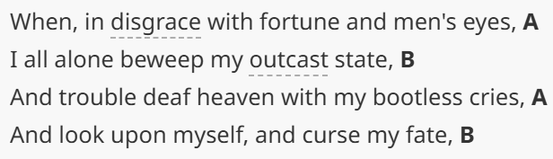
Types of rhymes:
- Perfect rhyme = when the sounds of two match exactly, usually by repeating the main stressed vowel and any consonants following it.
  - Masculine rhymes: rhymes of one stressed syllable
“reach and each”
  - Feminine rhymes: rhymes of two syllables that end on an unstressed note

“yellow and fellow”
  - Triple rhyme: rhymes involving three syllables

“greenery and scenery”

- Internal rhyme = the repetition of sounds within a line or verse.
“I took the car, and it wasn't far”
- Imperfect rhyme = constructions where the rhymes are only partial or slight correspondences of sound because only the vowel or the consonant sounds are repeated.
  - Consonance: when only the final consonant sounds correspond

“check and pluck”
  - Assonance: when only the internal vowel sounds correspond
“deep and meat”
  - Pararhyme: when the consonant order is repeated, but the vowels differ
“flesh and flash”
- Eye-rhyme = rhymes that only exists to the eye because the spelling rather than the sound chimes
“laughter and daughter”
- Alliteration (see above)

3.5 Theme
Does the poem have a theme? (Hint: they often have either a message or a theme). Remember to exemplify where the theme can be found.
- How is the theme developed?
You should also analyze who the voice in this poem is.
- Who is speaking and why has this poet written this poem? See if you can relate this to societal issues or the historical period the poem is written in.

