Film Analysis Guide

The broad picture
Horror films are both very different and very similar. They come in different forms, deal with different subject matter and use different effects to achieve their fairly similar aim; to entertain, scare and unsettle the viewer. Placing a certain movie in one of these categories does not say very much about the film and is not an end in itself. The list may, however, help us get an overview of the genre. It can also help us understand, why movies with certain characteristics often follow certain patterns. They do so because they adhere to and play on sub-genre conventions known to their viewers.

An analysis of a horror film can take its starting point in an attempt to place the movie in the chart and discuss how the director follows, mixes or plays with the conventions of the different sub-genres. At the end of the analysis you can return to the chart and consider if your initial categorization is still valid.

Zooming in
For any horror film to work, the director must establish the same things that the writer attempts to establish; identification, suspense, an uncanny atmosphere, shock, terror, resolution etc.

A first attentive and, if possible, dispassionate viewing of a horror film will probably leave you with a general impression and an ability to answer questions such as:

- Was it very explicit, gory and shocking or was it quiet and eerie?
- Did it work because you almost felt the pain and fear of the protagonists?
- Or did the film perhaps not manage to provoke an emotional response in you at all?You can, in other words, describe and discuss your experience with and response to the film. But if you want to know how this response and this experience were brought about, you need to zoom in.

What we focus on in this analysis is how the director uses cinematic techniques, which include both visual and aural devices. We do so to be able to answer questions like the following.

To understand and explain how this is actually done, we need to acquaint ourselves with the cinematic techniques and the language used to describe these techniques. Below you will find lists of terminology along with explanations, tasks and small exercises, which will enable you make an analysis of a horror film:

The components that make a film
Narrative structure
Most films adhere to a narrative structure which consists of three phases; setup, confrontation and resolution.

In the setup phase, the characters and the setting are introduced. What happens in this phase is primarily supposed to make the viewer familiar with the setting and the characters before they develop.

In the confrontation phase something happens which challenges or destroys the established order and forces the (main)character(s) to act and develop.

In the resolution phase of the film, the main character has adapted to the new situation and overcomes the final challenge after which order can be restored.

When we analyse a film, we can focus on questions like:
- Does the film follow the narrative structure described?
- What marks and establishes the transition between the different phases in the film?
- What characterizes the director’s use of different aural and visual techniques (see below) in the different phases?

A popular and firmly established feature of the genre is the use of foreshadowing, a tool which creates suspense and expectation with the viewers. Foreshadowing may be a strange look on a character’s face, a strange remark, an odd sound, an insignificant but ill-boding occurrence – really anything that throws the viewer off balance just a little and which suggests that something related but much worse will follow.

A closely related phenomenon is suspense – something which is often created either by withholding information from the viewers (which leaves you uncertain and guessing) or by giving the viewer information which the characters do not have (which leaves you wanting to warn the characters but, of course, unable to do so).

Foreshadowing and suspense are features so ingrained in the fabric of the genre that directors often play on the expectations and knowledge of the viewers by leaving false clues and establishing foreshadowing indicating one development only to shock the viewers with a different one

When focusing on this aspect in an analysis of a film, we can ask questions like:

- Are there elements, characters or actions to which our attention is directed in the early phases of the movie?
- What does the director do which makes us notice these things specifically?
- Do some of these elements return later in the film?
- If so, are they different? And how is this difference shown?
- Are there situations in which we are given more information than the characters?
- And which effect does this have?

Scenes that establish effects and phases like the ones mentioned above consist of images and sound. If images and sound are to establish strong emotional responses, they need to be constructed very carefully through a process in which the film crew and the director must make countless decisions on how to use the cinematic techniques available.

The elements that make a film
Technically a film can be divided into frames, shots, scenes and sequences. These are linked together through the processes of cutting and editing.

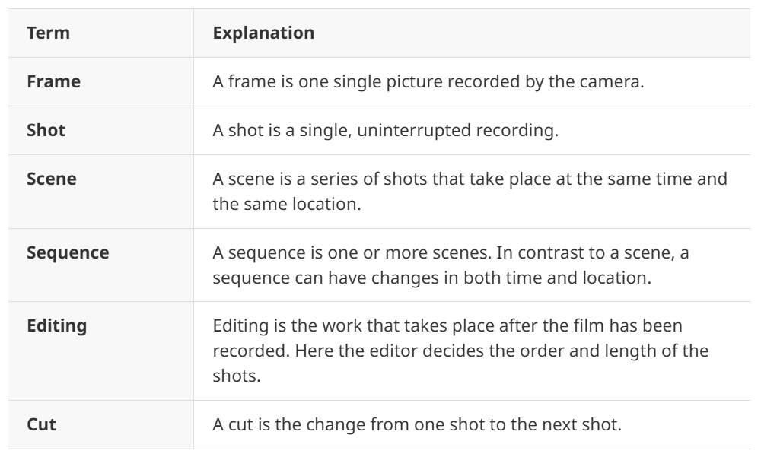

In an analysis of a film, you can choose to focus on single frames, which can be analysed like pictures and you can focus on specific scenes and analyse how they are constructed shot by shot through the process of editing and cutting.

When focusing on editing and cutting in your analysis of a sequence or scene, you may use the following questions:
- Is the cutting slow or fast?
- Does the pace change? If so, which effect does the change have?
- Is there a pattern in the way the cuts function?
- Does the cutting and editing give the audience a knowledge that the characters do not have?

The camera
Understanding what is done with the camera and which effects the different uses of the camera create is essential to an analysis of a horror film.

In your analysis, you must consider CAMERA DISTANCE carefully. Camera distance is the distance between the camera and the object.

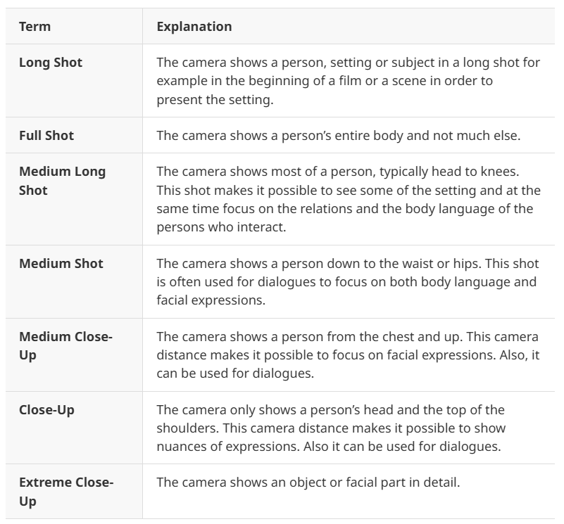

You can also focus on CAMERA MOVEMENT, where the following terms are useful.
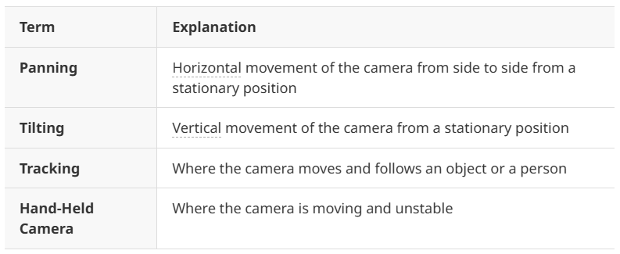
Finally you can consider CAMERA ANGLE. This refers to the specific location at which the camera is placed to take a shot. Where the camera is placed in relation to the subject affects the way the viewer perceives the subject.
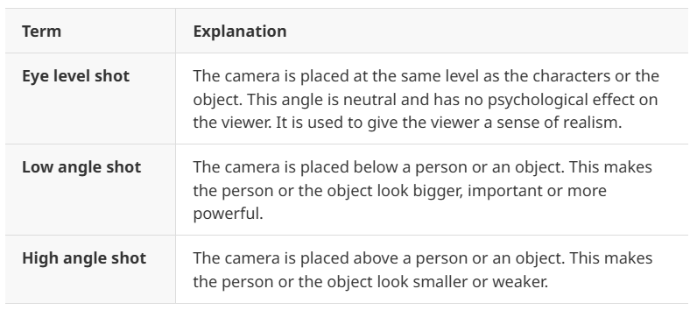

Sound and music
Anyone who has tried watching a horror film with the sound turned off has realized that the experience is very different and less intense. When you analyse a horror film it is important to consider the following:
- Are there many sound effects in the film?
- Is there a certain sound that returns many times in the film? If so, when and why does it return?
- What kind of music is used in the film?
- Does the music invoke a certain feeling or atmosphere?
- If so, how?
- Are parts of the music connected with certain characters or places in the movie?

Lighting and colour
The use of light, shadow and colour also gives the director many possibilities. The following questions can serve as a starting point in an analysis of these effects in a horror movie.What is lit and what is not lit in the film/scene/shot/frame?Are there any noticeable shadows? If so, how do they look and what do they cover?Does the use of light and shadow hide or reveal things to the audience that the characters may not see (this may also be symbolically)?Are there any predominant colours in the movie as a whole or in association with certain characters? If so, what may this signify or symbolize?

Film analysis Structure
Film Contents
- Film Facts:
- Genre:
- Setting:
- Plot and structure:
- Conflict:
- Characterization:
- Narrator and point of view:
- Imagery:
- Theme:

Cinematic Effects
- Soundtrack:
- Use of the camera:
- Lighting:
- Editing:

