How to analyze lyrics (A song)

1. Form
When you analyse the structure of a song, you should look at a combination of different elements. First, take a look at the song and consider how it is presented. You can ask yourself the following questions:
- How is it structured? (number of lines and stanzas, long or short lines, run-on lines)

2. Language
Besides looking at structure, you should also include the use of language in your analysis of the song. You may want to look at:
- Sentence structure (the use of long/short, correct sentence structure or unusual sentence structure)
- Choice of words (well-known, rare or self-fabricated words, slang, everyday language, use of sound words etc.)
- Word classes and whether some are used more than others and why (use of adjectives, verbs, nouns etc.)
- Style (formal or informal style, stream of consciousness)

Word use
If you want to do a more in-depth song analysis, you can dig even deeper into the use of language by asking yourself these questions:
  - Does the song express certain semantic fields and why?
  - What type of nouns are used - concrete or abstract or other - and what is the effect of this?
  - What type of verbs are used and to what effect?
    - sensory (e.g. taste, smell, feel)
    - action (e.g. run, swim, listen, believe)
    - stative (e.g. love, hate, need, have)
    - linking (e.g. be, seem, appear, become)
    - helping (e.g. do, be, can, will)
  - What is the tone of the songand how can you tell? (everyday, naive, serious, fun, playful, humorous, sad, passionate, mournful, indignant, elated, sentimental etc.)

3. Imagery and other rhetorical devices
In song rhetorical devices and imagery can appear. It’s important to describe the effect of these. Examples of these include:
Tropes:
- METAPHORS = A word or expression is used in a transferred or figurative sense. A metaphor is based on a relationship between two elements, and the metaphor replaces one element with the other
“the autumn of life”
  - DEAD METAPHORS = the metaphor no longer creates any new meaning
“table leg”

  - LITERARY METAPHORS = the metaphor creates new meaning that extends beyond the two elements involved

“life is a highway”
- SIMILE = When two concepts, things, or feelings are compared explicitly (as opposed to the metaphor, where the comparison is implicit). This could be indicated by the word “like” or “as”.
“Pretty like a rose”
- METONOMY = When something associated with an object or idea stands in for the idea itself.
“the White House has issued a statement”
  - SYNECDOCHE = A form of metonymy in which one part of an object or idea stands in for the while of that object or idea.

“Ask for her hand”
- PUN = When a word is understood in at least two different ways at once.

“A Cross-eyed teacher could not control his pupils”
- CONCEIT = When a metaphor is extended and explored so that it becomes the governing idea of a song.

In this poem, two lovers are being compared to a compass.

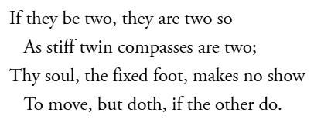

- PERSONIFICATION = When an abstract concept or inanimate object is given human attributes.
“The wind whispered secrets through the trees”

- APOSTROPHE = A ‘vocalized’ address within a song directed at an inanimate object, abstract concept, or an absent figure.
“You! Reading this”
- ALLEGORY = An extended metaphor in which events and actions within a narrative imply a separate series of events and actions ‘outside’ the song.

The story of the Tortoise of the Hare represents the bigger idea, that being slow and steady wins over being fast and not thorough

Schemes:
- ANAPHORA = repeating words at the beginning of successive phrases or clauses.

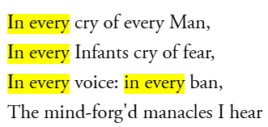

- ANATROPHE = The jumbling of parts of a sentence or phrase.
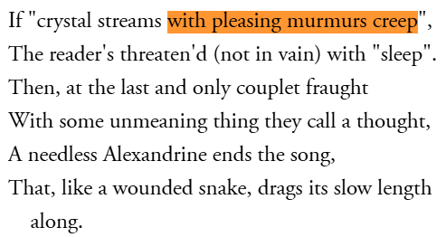
- EPISTROPE = the repetition of words at the end of successive phrases or clauses.

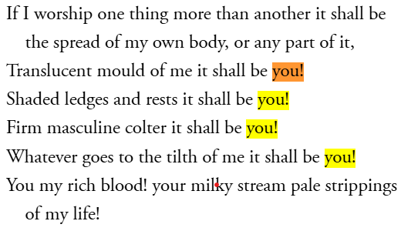

- CHIASMUS = Two successive phrases or clauses switched around to create a cross shape.

“Ask not what your country (A) can do for you (B)
ask what you (B) can do for your country (A)”

- ZEUGMA = When one word refers in the same way to two or more other words in a phrase.
“You held your breath and the door for me."
- SYLLEPSIS = a zeugma in which the governing word applied differently to each of the referent words.
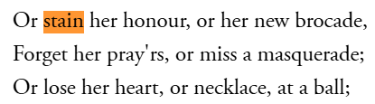
- ANTITHESIS = Juxtaposes contrasting ideas in a balanced structure
"To err is human, to forgive divine"

- ONOMATOPEIA = words that mimic sounds
"buzz”
- ALLUSION = A brief reference to a well-known person, place, thing, or idea
“Achilles heel”
- REPETITION = Repeating words or phrases for emphasis

(Look at ‘Anaphora’)
- ALLITERATION = Repetition of the same initial consonant sound in nearby words
"Peter Piper picked..."
- EUPHEMISMS = An indirect word or phrase that people use to refer to something embarrassing or unpleasant
Die “pass away”

4. Rhyme
Does the song rhyme? You can indicate rhyme by giving the word a letter: a, b, c, d or more. An example could be:
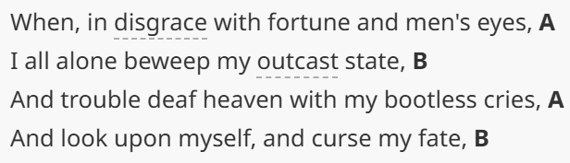
Types of rhymes:
- Perfect rhyme = when the sounds of two match exactly, usually by repeating the main stressed vowel and any consonants following it.
  - Masculine rhymes: rhymes of one stressed syllable
“reach and each”
  - Feminine rhymes: rhymes of two syllables that end on an unstressed note

“yellow and fellow”
  - Triple rhyme: rhymes involving three syllables

“greenery and scenery”

- Internal rhyme = the repetition of sounds within a line or verse.
“I took the car, and it wasn't far”
- Imperfect rhyme = constructions where the rhymes are only partial or slight correspondences of sound because only the vowel or the consonant sounds are repeated.
  - Consonance: when only the final consonant sounds correspond

“check and pluck”
  - Assonance: when only the internal vowel sounds correspond
“deep and meat”
  - Pararhyme: when the consonant order is repeated, but the vowels differ
“flesh and flash”
- Eye-rhyme = rhymes that only exists to the eye because the spelling rather than the sound chimes
“laughter and daughter”
- Alliteration (see above)

5. Theme
Does the song have a theme? (Hint: they often have either a message or a theme). Remember to exemplify where the theme can be found.
- How is the theme developed?
See if you can relate this to societal issues or the historical period the period.

