A Girl that demanded School – Kakenya Ntaiya (Kenya) - <https://www.ted.com/talks/kakenya_ntaiya_a_girl_who_demanded_school?subtitle=en>

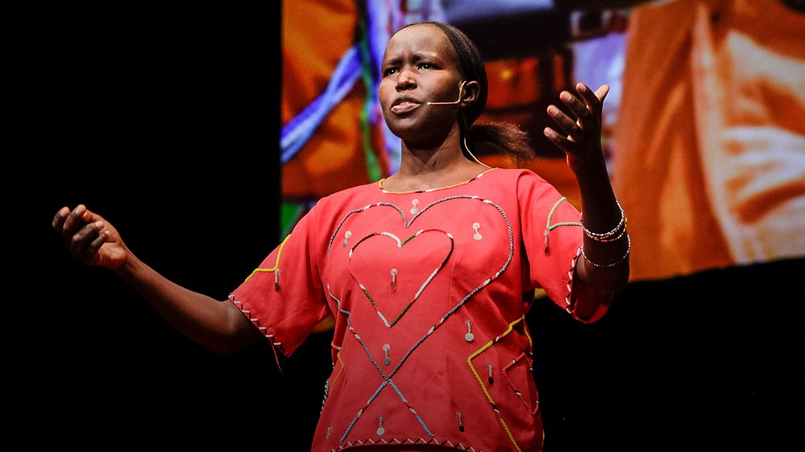

Malala Yousafzai (Pakistan) – “We are facing an education emergency” (2.54 min.)

<https://www.youtube.com/watch?v=bEi8ADfYVEI>

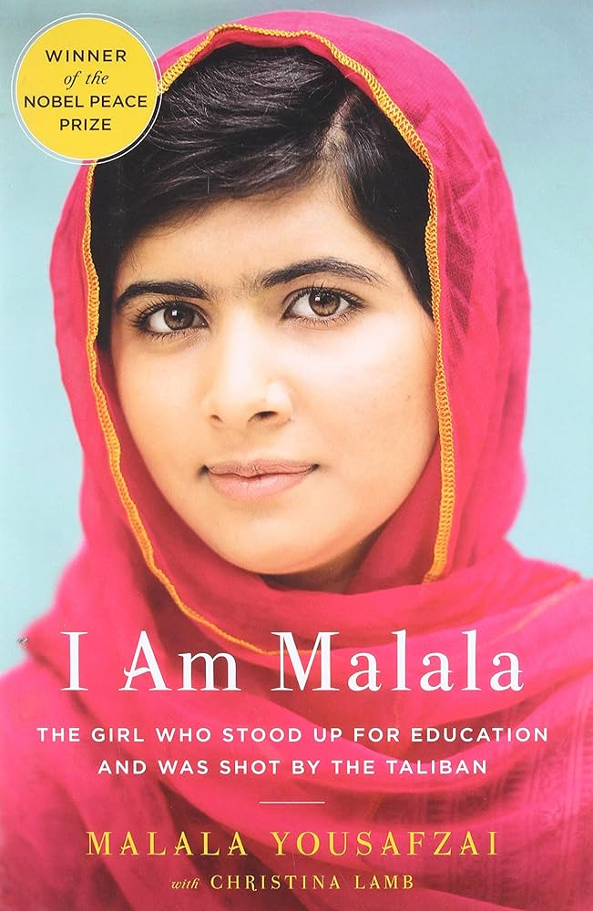<https://www.facebook.com/brutindia/videos/380502379097574/>