Describing two Kensingtons – London and Liverpool

Write a short description (a text of 50-75 words) of each of the environment in each of the two photos. Write complete sentences instead of singular words. - Use at least 5 adjectives and 5 adverbs in each of your descriptions. Highlight / underline the words.

Kensington, Liverpool  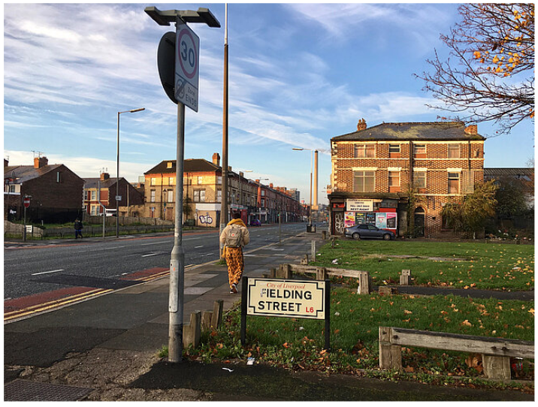 | 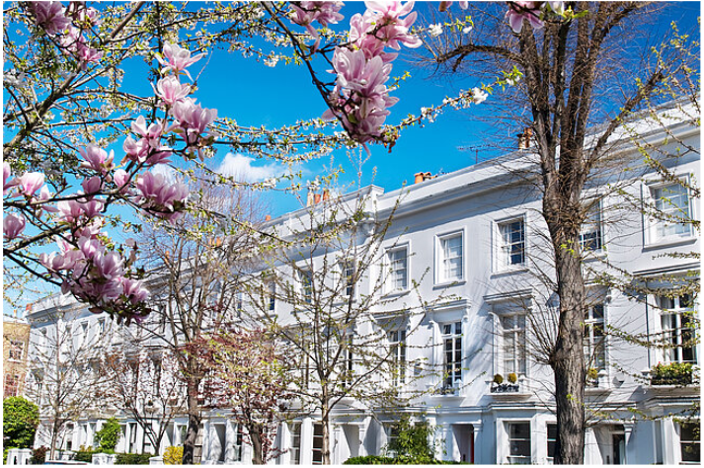  Kensington, London

