Assignment 1
Vælg tre verballed (udsagnsled) fra nedenstående tekststykke, og omskriv dem til henholdsvis perfektum (førnutid), præteritum (datid) og pluskvamperfektum (førdatid), som angivet i skemaet nedenfor.

Deepfakes are based on technology known as generative adversarial networks in which two algorithms train each other to produce images.
While the technology behind deep fakes may sound complicated, it is a simple matter to produce one. There are numerous online applications such as Faceswap and ZAO Deepswap that can produce deepfakes within minutes.
[...]
Deepfakes are the perfect tool for disinformation campaigns because they produce believable fake news that takes time to debunk. Meanwhile, the damages caused by deepfakes — especially those that affect people’s reputations — are often long-lasting and irreversible.
Sze-Fung Lee and Benjamin C. M. Fung, “The use of deepfakes can sow doubt, creating confusion and distrust in viewers”

Dit 1. verballed fra teksten | Din omskrivning af verballed til perfektum
Dit 2. valgte verballed fra teksten | Din omskrivning af verballed til præteritum
Dit 3. valgte verballed fra teksten | Din omskrivning af verballed til pluskvamperfektum

Assignment 2
Find verballeddene (udsagnsleddene) i nedenstående fem sætninger.
Indsæt verballeddene fra sætningerne i skemaet herunder, og angiv, hvilken tid de står i. Afgør for hver sætning, om verballeddet er aktivt eller passivt.

- In early March, a manipulated video of Ukrainian President Volodymyr Zelenskyy was circulated.
- However, deepfakes are used successfully in assistive technology.
- Yet every coin has two sides.
- Deepfakes are the perfect tool for disinformation campaigns.
- Trump used misinformation in defence of his wrongdoings and as a propaganda tool.

Uddrag fra: "The use of deepfakes can sow doubt, creating confusion and distrust in viewers"

 | Verballed | Tid | Aktiv/passiv
1.
2.
3.
4.
5.

Assignment 3
Skriv en sammenhængende tekst om billedet på 75 til 125 ord, hvor du anvender følgende fem præpositioner (forholdsord): on, in, at, to, with.
Marker de fem forskellige præpositioner i din tekst.

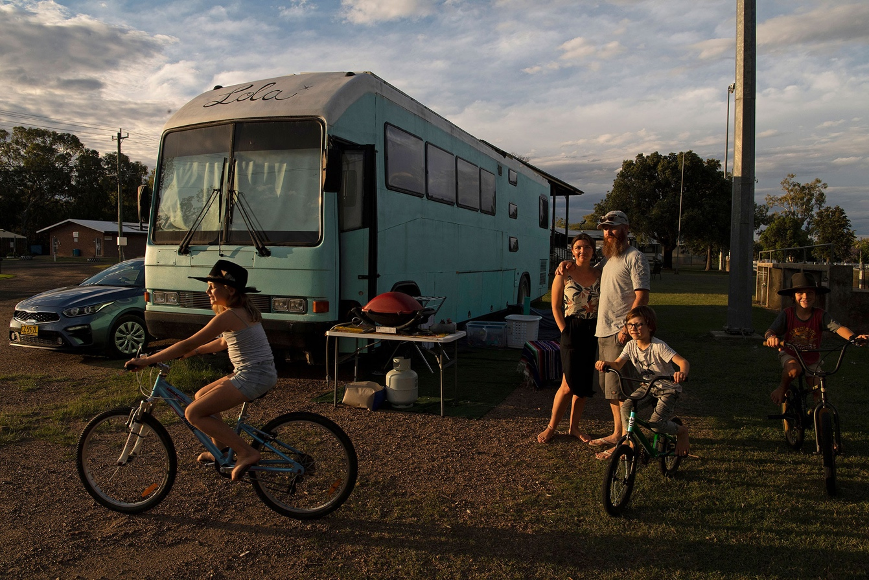
Foto af Louise Kennerley (2022)

Din tekst

Assignment 4
Find fem adjektiver (tillægsord) i videoklippet, og find et synonym til hvert tillægsord, der passer ind i konteksten. Udfyld skemaet nedenfor.

Bemærk, at du skal afspille videoklippet i selve opgaven under Assignment 4.

 | Adjektiv | Synonym
1.
2.
3.
4.
5.

Assignment 5

