**Cross cultural communication – 12th of January**

The topic of today’s group work is **CROSS CULTURAL COMMUNICATION**, and the time frame is **8:30 - 11:50 a.m.**  **You are working on your own**, but you may consult your teacher.

|  |  |
| --- | --- |
| Group 1 | Catrine, Melanie, Victor, Matthias |
| Group 2 | Clara, Nikoline, Tobias, Marcus |
| Group 3 | Freja A, Sarah, Oliver, Andkjær |
| Group 4 | Freja L, Silja, Nicolai, Kasper, |
| Group 5 | Mathilde, Sille, Matvei, Klitten |
| Group 6.1 | Gustav, Frederik, Carl |
| Group 6.2 | ---- |
| Group 7 | ---- |

**8:30 – 9:30 a.m.**

A: Get in your assigned group.

B: Read the task on the last page thoroughly so you know what to do for the day.

C: All group members must read/watch all “sources” and write down keywords for what you consider being the most important points to remember.Important to bear the assignment in mind while reading/listening.

**9.40 – 11.30 a.m.**

A: Plan and record your video (or your cartoon if you choose that option). Remember no manuscript or reading out loud!

B: Upload your video/cartoon on Lectio under Opgaver 🡪 Cross-Cultural Communication video

**11.30 – 11.50 a.m.**

**A: Individual work**: You must speed write **for 15 minutes**. Use your own words (no copy-paste), write in full and coherent sentences. You must address: 1) what you have learned about cross-cultural communication, and 2) how was your own and your groups performance?

B: Submit it to Lectio under Opgaver 🡪 Individual Reflections – cross-cultural communication.

**SOURCE 1:**

**Is globalization creating a single world culture?**

The homogenizing[1] forces are as strong as the heterogenizing[2] forces. In short, in the globally connected world, we might not be as homogenized as we assume to be.[3]

**SOURCE 2:**

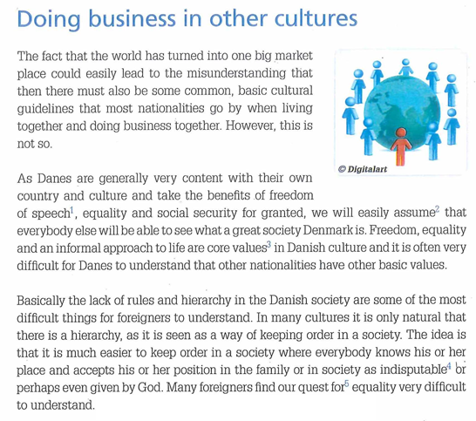



# Source 3:

# Cross Cultural Communication: 3 basic aspects of culture, *27 August 2020, (8:22)*

# <https://www.youtube.com/watch?v=0SNGe0AtV3s>

# Source 4: Essential Tips for Doing Business with India

## Almost every enterprise in the west is looking at collaboration and business links with India – but it is not easy, it requires patience and a lot of understanding.



## 1. The language barrier is real

India has some 26 major languages, but your Indian counterpart will almost certainly speak English, which itself is a problem – it creates the illusion of communication and understanding. Many of us speak English and think western – your Indian partner speaks English and thinks Indian, so take care to build real understanding. Also keep in mind there are “many Indians” with many different languages and ways of thinking.

## 2. Avoid stereotyping

India might be the most diverse country on earth. Religions, beliefs, languages and culture all immensely varied. Keeping an open mind will help you avoid jumping to the wrong conclusions. Your host could have spent many years in the USA or the UK, and have a global outlook – or never have left India and have a regional view.

## 3. Prepare for the collective

Most westerners come from a culture of the individual, but Indians are firmly placed in a collective culture. A visitor to an Indian company will often find four or five Indians in the meeting, and often it is not clear who is in charge. Many Indian leaders will not speak up or even speak at all in these meetings – in the collective someone else does the talking while they do the evaluating.

## 4. You are just one of many

The world is knocking on India’s door. Even if you represent a major company, you are not that important to Indians. The rest of the world is chasing them too, so they have choices. While most western executives are under head office pressure to complete the deal, their Indian counterpart faces no such demand and can walk away in most cases.

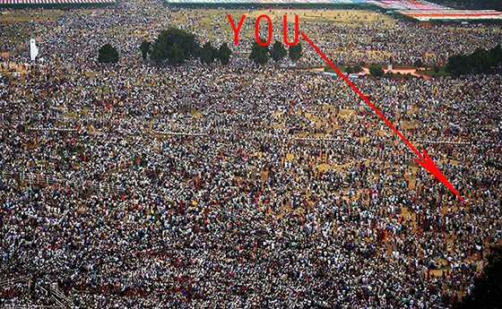

## 5. Be prepared for paradox

Visitors can be shocked and unprepared for the speed of modern India. Businesses need to be prepared to deliver on a product or service immediately and not just have some idea for a future opportunity. Trade missions from around the world arrive weekly, so they have plenty of choice. Fast and slow, east and west – India is a living paradox.

## 6. Watch out for religious holidays

A simple point often overlooked - check the calendar for holidays and although they are often fun and informing, it is a hard time to do business. A holiday listed for one day might run for four, so check it out first.

## 7. Start and end the day late

Indian breakfast meetings can be set for 10am or even later – they are late starters (even though PM Modi has instructed Ministers to be at their desks by 9am). But your dinner meeting at the end of the day might not start until 9pm or later. Hours are long and weekends are for working because “work is life” is the mantra.



## 8. Things will change at the last minute

Despite your expectation, India runs to its own rhythm. One westerner tried to break convention by running an early (6.30pm) dinner meeting, and his guests showed up at 9.30pm anyway. Often you will be called minutes before a meeting to change time or venue – going with the flow is an asset over there.

## 9. Expect to be interrupted

Indians like to do several things at once, so expect your presentations to be interrupted by other visitors, cell phones, papers to sign and other distractions. At formal conferences and lunches, cell phones are rarely switched off and often answered at full voice. Western focus and single-mindedness is not an asset in India.

## 10. Be more formal

Addressing people by a title and their last name is a good policy in a country where status and formality underpin good manners. Casual forms of address can come later, but only once you have really got to know the Indian partner very well. On the other hand, things are changing so fast in India…

## 11. Navigate through the spider web

While the west strives for simplicity and certainty, Indian business leaders know that life is like trying to find your way through a spider web – where does it begin, where does it lead, who can tell? Consistent with this view, most Indian corporations offer an incredibly diverse range of products and services – whereas western business tends to focus on just one area. In most cases Indian companies are willing to buy from you but are also looking for the deal to include some intellectual property sharing arrangements – think about these before you head over there.

## 12. Learn the art of flexibility and patience

Being patient and flexible is an asset, even if you come from a country that likes to be blunt, direct and structured. Most Indian communication is indirect so it can take some time to work out what the real issues are. India is full of surprises and you cope best through being flexible. Dropping any “one rule for all” approach is a good start.

If you are thinking of going, India’s great thinker Rabindranath Tagore can be your inspiration: “You can’t cross the sea merely by standing and staring at the water.”

Adapted from: <https://www.aii.unimelb.edu.au/blogs/20-essential-tips-for-doing-business-with-india/>

**Assignment**

Today’s assignment is twofold. Firstly, you are to make a video in groups. All group members must participate equally. Duration: 6-8 minutes. Secondly, you must do individual reflections.

1. In your video, include the following:
2. In your own words, sum up the main points that are presented in the text *Essential tips for doing business in India*.
3. Explain and comment on the quote “You can’t cross the sea merely by standing and staring at the water” (*Essential tips for doing business in India*)
4. Explain the quotation: “*The homogenizing forces are as strong as the heterogenizing forces. In short, in the globally connected world, we might not be as homogenized as we assume to be.”* Do you agree with this point of view?
5. You now know a lot about how to act – and how not to act – in dealing with an Indian partner. Film a meeting between an Indian and an English person in which cultural blunders are a prominent feature. All group members must participate in this part of the video.

For task number 4, you can choose between the following options:

* 1. Record the meeting with your phone.
  2. Make an animated cartoon (using a tool like Pixton) to visualize the meeting and then speak over it in screen-cast.

**Upload your video/cartoon** to Lectio<Opgaver<Cultural Awareness at **11.30. a.m.**

1. From **11.30-11.50 a.m.,** you must work on your personal reflections and upload them by the end of class.   
   **Individual work:** You must speed write for 15 minutes. Use your own words (no copy-paste), write in full and coherent sentences. You must address: 1) what you have learned about cross-cultural communication, and 2) how was your own and your groups performance?



1. ensartede
2. forskelligartede
3. <https://www.quora.com/As-the-world-is-getting-more-and-more-connected-will-human-be-uni-cultural-in-the-near-future>