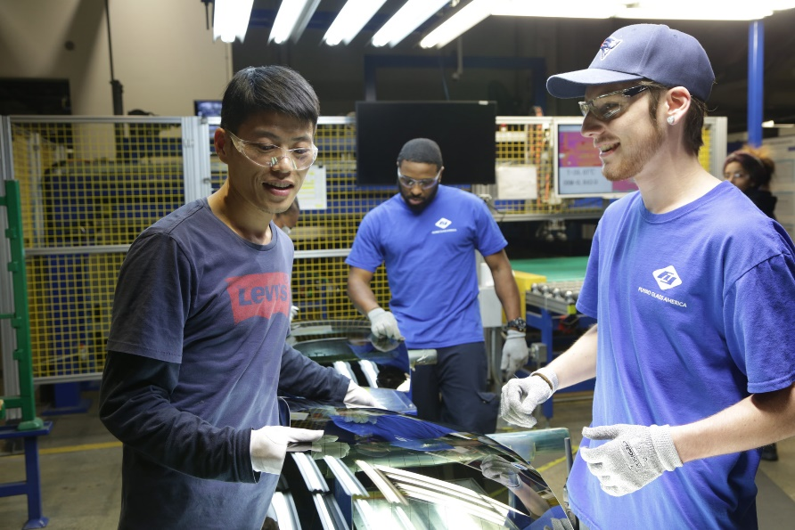What is *American Factory?*Documentary from 2019.  
Produced by Netflix.

**Summary:**

“In post-industrial Ohia, a Chinese billionaire opens a factory in an abandoned General Motors plant, hiring two thousand Americans. Early days of hope and optimism give way to setbacks as high-tech China clashes with working-class America.”

(IMDB: <https://www.imdb.com/title/tt9351980/>)

Tasks for *American Factory* (2019):

**While watching the documentary you must answer the following questions thoroughly. We’ll have a discussion based on your answers during tomorrow's lessons:**

1. **Make three questions regarding the content of the documentary which could be interesting to discuss.**
2. **What does it mean that Fuyao wants to be a global company with both Chinese and American culture?**
3. **How does the Chinese company chair/CEO perceive the American employees and managers? (Use examples from the documentary)**
4. **How does the American management perceive the Chinese employees when they visit the company in China? (use examples from the documentary)**
5. **List some of the cultural differences regarding manager/employee relations, motivation, and efficiency.**
6. **What is the Chinese company’s opinion on unions? What does the American employees think about unions?**