*Astronomy Activity*

***HOW FAST ARE WE MOVING?***

**What you should already know**

Hopefully, you should have already learned of four ways we move about in the Universe. We live in an age where we learn these ideas in school, but there was a time in human history where none of these motions were suspected because we never “feel” the motion. Most likely, YOU have never felt any of these motions....yet they do happen!

1. We (surface creatures) move in a circle around the axis.
2. We (planet) move in a (near) circle around the Sun.
3. We (Solar System) move in a (near) circle around the center of the Milky Way Galaxy.
4. We wobble in a circle around a line perpendicular to the ecliptic (This one can be left for extra credit)

So we move…but how fast? Well “fast” is speed, and speed is distance/time. And in these cases, the distance we travel is a (near) circular path.

So the first thing is to **know the formula** for the “circly distance path thingy”, which is ___________________

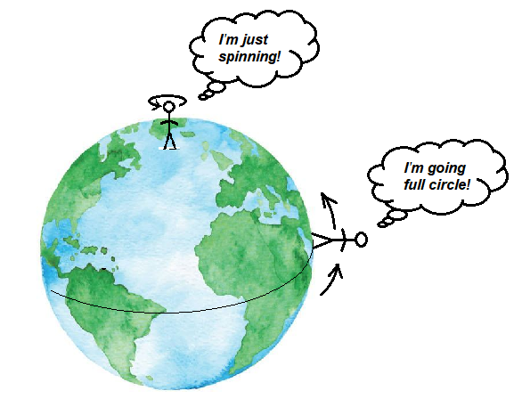

1. **“Axis circling” is called** ____________________________

Assume that you are at the equator where the “fastest” humans are.

How far are you from the axis? ___________________________km (let’s do kilometers)

*Cite your source:* ____________________________________________

How far is one complete circle trip? __________________________ km

Show your work here

How long does it take to do one circle? _________________________ (let’s do seconds)

Show conversion work here

How fast is an Equatorian moving?__________________km/s

Show work here

1. **Sun Orbiting is called** 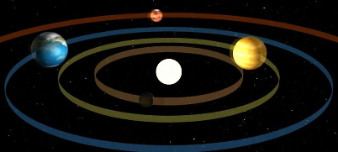

____________________________

How far are you from the Sun? _____ (let’s do AU’s …very little space on the blank line is for a reason)

How far are you from the Sun?

_____________________________________ (let’s do kilometers)

*Cite your source:* ____________________________________________

How far is one circle trip? __________________________________ km

Show your work here

How long does it take to do one circle? ___________________________________ (let’s do seconds)

Show conversion work here

How fast is an Earth passenger moving around the Sun?__________________km/s

Show work here

1. **Milky Way Orbiting (no special name)**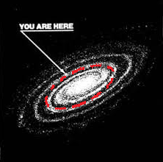

How far are you from the center of the Milky Way? __________________l.y. (let’s do light years)

*Cite your source:* ____________________________________________

How far are you from the center of the Milky Way?

____________________________ (let’s do kilometers)

Show conversion work here

How far is one circle trip? __________________________ km

Show your work here

How long does it take to do one circle? ______________________ years

*Cite your source:* ____________________________________________

How long does it take to do one circle? _________________________ (let’s do seconds)

Show conversion work here

How fast is an “Sun-arian” moving?_________________________km/s

Show work here