Restriktionsenzymer

Eksempler på restriktionsenzymer:

1. Klip figurerne ud, og klip i DNA’et der hvor hhv. Eco RI, Bam HI og MstII

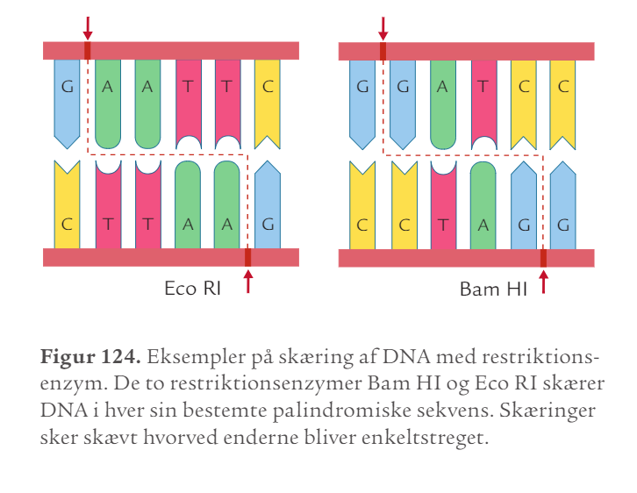

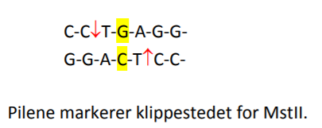

Nedenfor er angivet et udsnit af genet for β-kæden i hæmoglobin. (Det er ikke den korrekte sekvens).

Udsnit af det normale gen for β-kæden:

|  |  |  |  |  |  |  |  |  |  |  |  |  |  |  |  |  |  |  |  |  |  |  |  |  |  |  |  |  |  |  |  |  |  |  |  |  |  |  |  |
| --- | --- | --- | --- | --- | --- | --- | --- | --- | --- | --- | --- | --- | --- | --- | --- | --- | --- | --- | --- | --- | --- | --- | --- | --- | --- | --- | --- | --- | --- | --- | --- | --- | --- | --- | --- | --- | --- | --- | --- |
| A | T | T | T | C | G | C | G | T | T | A | A | T | C | C | C | G | C | A | T | T | C | C | T | G | A | G | G | A | G | T | A | C | G | T | C | C | C | A | A |
| T | A | A | A | G | C | G | C | A | A | T | T | A | G | G | G | C | G | T | A | A | G | G | A | C | T | C | C | T | C | A | T | G | C | A | G | G | G | T | T |

Udsnit af genet for seglcelleanæmi (β-kæde med punktmutation):

|  |  |  |  |  |  |  |  |  |  |  |  |  |  |  |  |  |  |  |  |  |  |  |  |  |  |  |  |  |  |  |  |  |  |  |  |  |  |  |  |
| --- | --- | --- | --- | --- | --- | --- | --- | --- | --- | --- | --- | --- | --- | --- | --- | --- | --- | --- | --- | --- | --- | --- | --- | --- | --- | --- | --- | --- | --- | --- | --- | --- | --- | --- | --- | --- | --- | --- | --- |
| A | T | T | T | C | G | C | G | T | T | A | A | T | C | C | C | G | C | A | T | T | C | C | T | G | T | G | G | A | G | T | A | C | G | T | C | C | C | A | A |
| T | A | A | A | G | C | G | C | A | A | T | T | A | G | G | G | C | G | T | A | A | G | G | A | C | A | C | C | T | C | A | T | G | C | A | G | G | G | T | T |

1. Klip de 2 DNA-sekvenser ud. Find klippestedet for MstII og klip.
   1. Hvad er resultatet?
   2. Forestil dig, at du har rigtig mange af disse DNA-sekvenser som er klippet med MstII. Hvordan vil de adskilles på en elektroforesegel? (husk: små DNA-stykker vandrer længere i gelen end lange DNA-stykker)