The King’s Speech (2010)

**A: Insert the correct form of the verb (present tense):**

*The King’s Speech ______________* (to tell) the story of the man who ____________ (to become) King George VI, the father of Queen Elizabeth II. After his brother ________________ (to **abdicate**), George ('Bertie') reluctantly ___________________(to assume) the throne. Plagued by a dreaded **stammer** and considered unfit to be king, Bertie ______________ (to engage) the help of an unorthodox **speech therapist** named Lionel Logue. Through a set of unexpected techniques, and as a result of an unlikely friendship, Bertie ___________ (to be) able to find his voice and boldly lead the country through war.

A1: **Explain (in Danish) the grammar in the underlined sentence:**

A2: **Use the words in bold in three new sentences:**

1.

2.

3.

Word classes – find the equivalent noun:

|  |  |
| --- | --- |
| **Verb** | **Noun** |
| To abdicate |  |
| To stammer |  |
| To assume |  |

1. **Answer the questions:**
2. ”Bertie” is the main character, but who is he, and how would you characterize him?
3. Why does he become king?
4. Describe how Bertie overcomes his stammer. Which techniques?
5. Comment on the title
6. How many Oscars did the film win? Why, in your opinion?

**C: Comment on the film poster** – why do we for instance see an extreme close-up of the king’s mouth and a microphone?

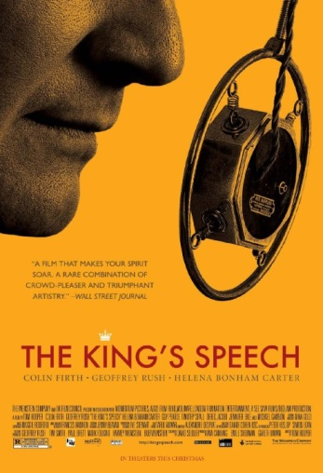

**D.** Write a summary of Tom Hooper’s film *The King’s Speech* (2011)in about 150 words.

________________________________________________________________________________________________________________________________________________________________________________________________________________________________________________________________________________________________________________________________________________________________________________________________________________________________________________________________________________________________________________________________________________________________________________________________________________________________________________________________________________________________________________________________________________________________________________________________________________________________________________