## Indigenous life expectancy comparison

To calculate Indigenous life expectancy across countries the UN compared health statistics of Indigenous people in America, Australia, Canada and New Zealand over the past 10 years.

Australian Aboriginal people's life expectancy is by far the worst. They die 20 years before the average non-Indigenous Australian dies.

**Table 1.**

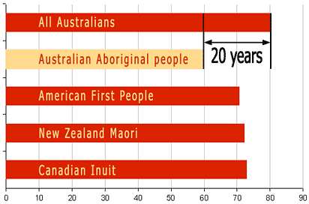**Indigenous life expectancy.**

While Indigenous peoples of the Americas and the Maori live over 70 years, Indigenous Australians on average barely reach 60 years.

The difference in life expectancy between Indigenous and non-Indigenous people was the greatest for Australia: Non-Indigenous Australians live on average 20 years longer than Aboriginal Australians. For the other nations, the gap is between 4 and 10 years.

Causes for this poor health and low life expectancy include:

* poverty
* poor nutrition
* poor housing
* dispossession of their traditional lands
* low education level
* high unemployment
* hidden racism
* inability of politicians to address Indigenous problems