The Frontier
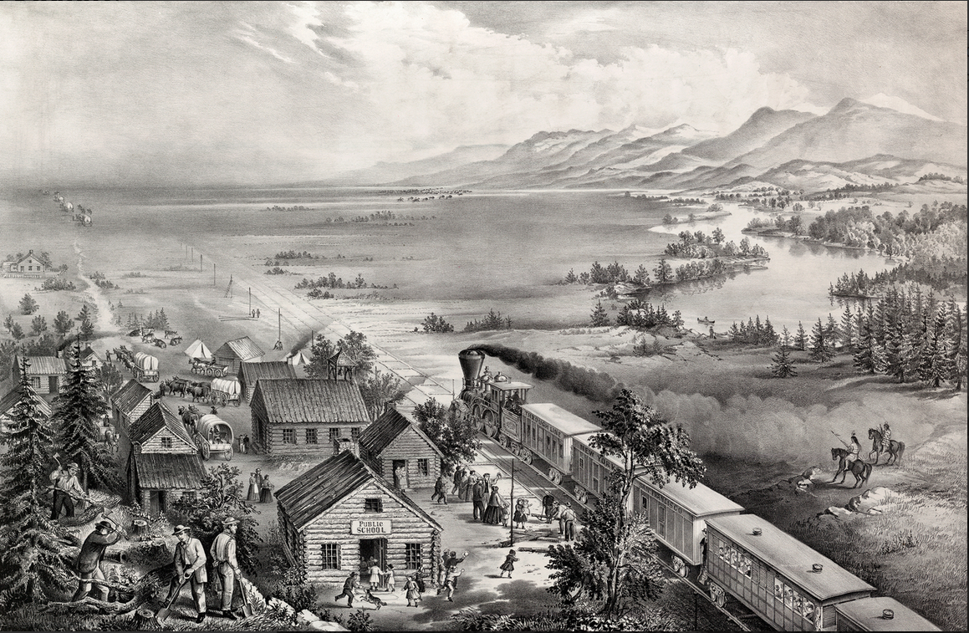
Few other phenomena have shaped American life and American character as much as the Frontier; that ever-moving line which marked the edge of civilisation on the North American continent, from the original thirteen colonies on the East Coast, until the settlers had reached the Pacific Coast in the early 20th century. Frontier ideology is closely associated with the idea of Manifest Destiny; that Americans are destined to rule the entire North American continent. In 1893, theorist Frederick Jackson Turner went so far as to argue that the Frontier was the very creator of true American character.
(…) Life on the Frontier was challenging and dangerous; turning uncultivated land into farming land is a back-breaking task in itself, and then add the threat of attacks from native Americans, marauding criminals, wild animals, and the sheer force of nature itself. It's no wonder that many settlers died or had to give up and move back to more civilised areas. (…) You can also explore Frontier life in the excerpt from Roughing It where Mark Twain wittily describes how quickly conditions changed on the Frontier. Twain hilariously describes the hardships of travelling by stagecoach in the 1860s, and then how easily the very same journey could be made ten years later when railways had altered travel significantly.
In 1931, James Truslow Adams coined the phrase "the American Dream". At first, the American Dream had promised "opportunity for each according to his ability or achievement", but during the 20th century, the dream changed into a dream of home ownership, a good job, and a comfortable life. (…)
In the middle of the 20th century, it seemed that there was no limit to US technology. The Manhattan Project, and the two nuclear bombs over Hiroshima and Nagasaki in 1945 had made the US look almost invincible. America took on a new role as "policeman of the world", fighting a number of wars around the world.
The idea of American exceptionalism and the quest for global leadership are concepts that are deeply ingrained in American self-perception. They date back to a famous sermon from 1630 when John Winthrop declared that the newly founded Massachusetts Bay colony would shine like "a city on a hill" and thus differ from the rest of the world. (…)
Out of the experiences with nuclear bombs during World War II, the Space Age emerged. Divided by the Iron Curtain, the US and the USSR competed in technological leadership of outer space, which became the new American frontier, as declared by President John F. Kennedy in his 1962 speech on the nation's space effort. The USA did win the Space Race when successfully landing two astronauts on the Moon in 1969 and several times in the 1970s with the Apollo space flights. Even though the US space programme has also caused deaths, such as the explosion of the space shuttle Challenger in 1986, it has been tremendously significant since what began as a race for supremacy has paved the way for scientific breakthroughs and many modern technologies. (…)
In the world of today, geopolitical power and technological leadership are inextricably linked, and the US has been in the lead for a long time. However, the US is losing its foothold to other nations, especially China. China's economy is now the world's second largest, and as the Chinese government has invested heavily in new technologies, China is set to challenge the US for technological leadership and economic supremacy.
The fact that the two countries have very different political standpoints and geopolitical ambitions does not lessen the tension between them. The US considers the technology race one of the most substantial trials in the near future, and there is much to suggest that the battle between the US and China will primarily be a battle in technology.

