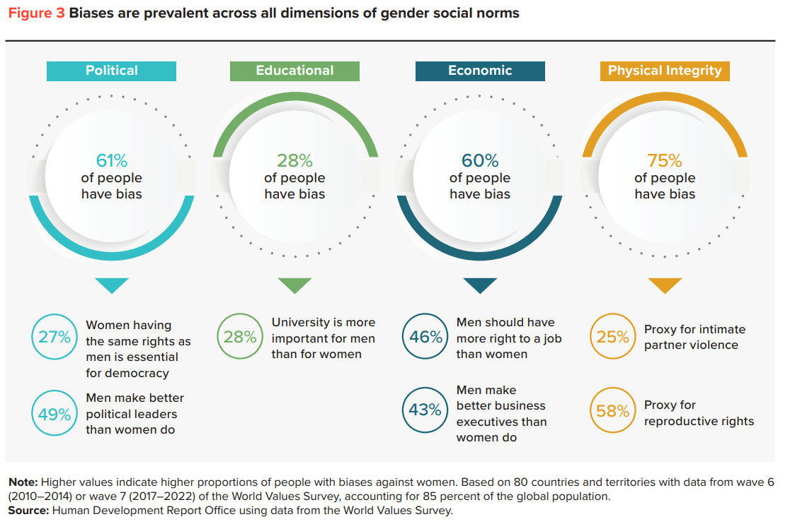
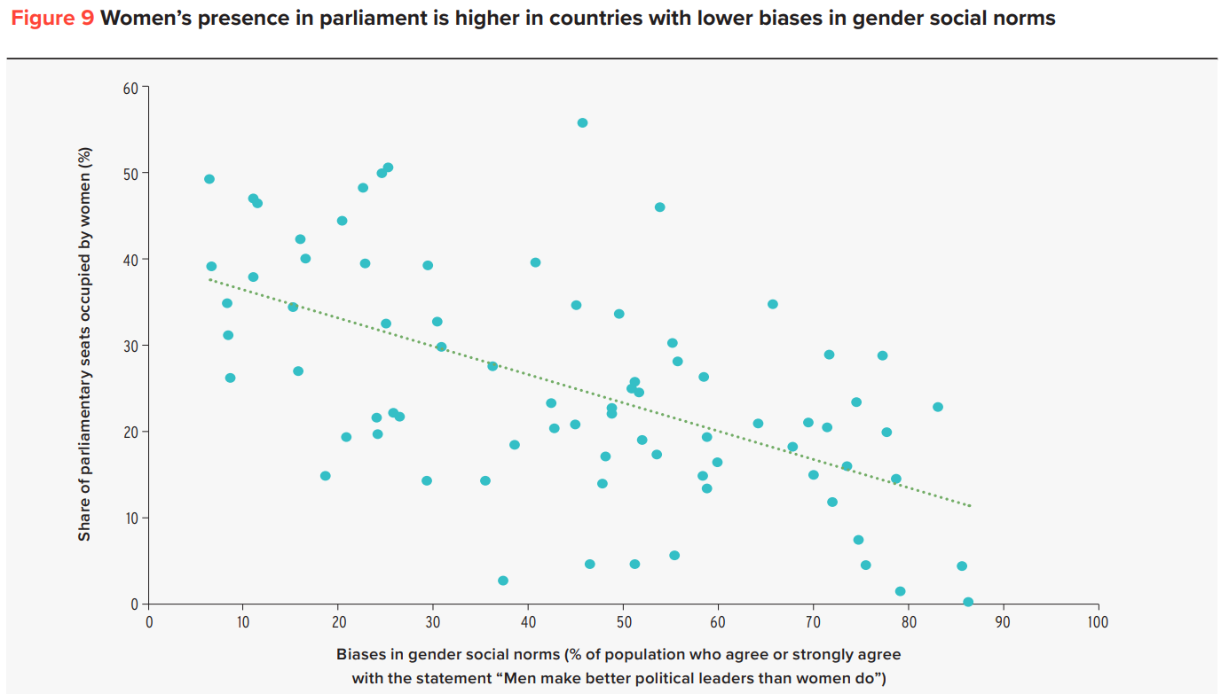
https://hdr.undp.org/system/files/documents/hdp-document/gsni202303.pdf

