

The collapse of Venezuela, explained



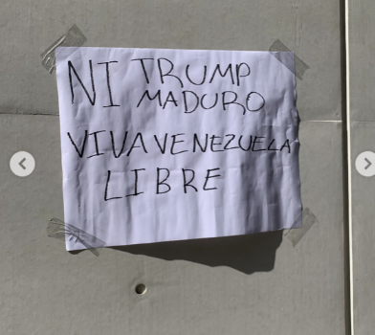

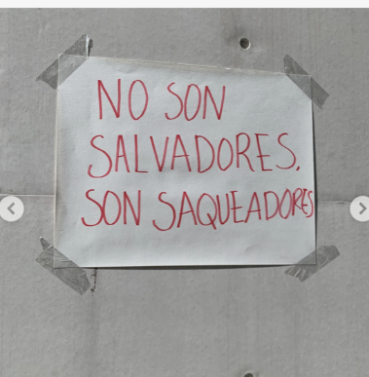

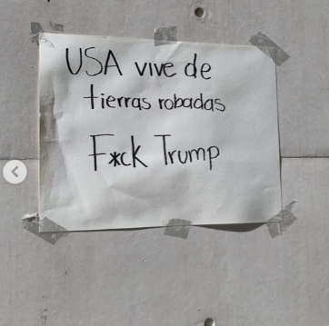



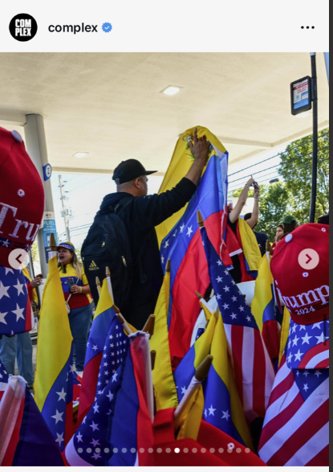

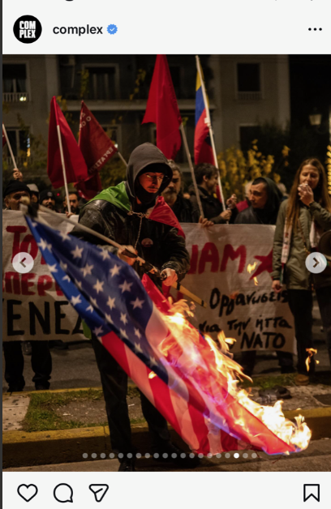

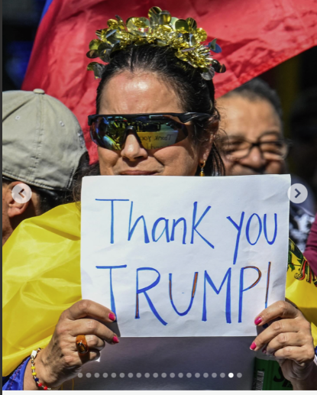

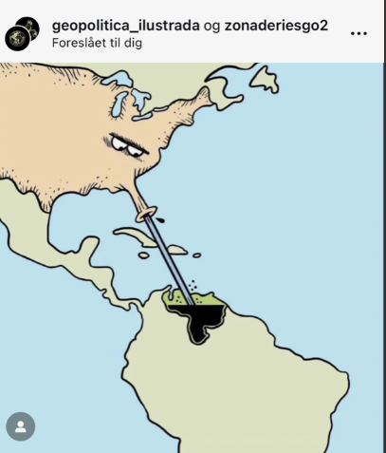

https://www.instagram.com/reel/DTGD2G2CVVE/?utm_source=ig_web_copy_link&igsh=MzRlODBiNWFlZA==

https://www.instagram.com/reel/DTDfD_9EhRj/?utm_source=ig_web_copy_link&igsh=MzRlODBiNWFlZA==

https://www.instagram.com/reel/DTDoAvqjulw/?utm_source=ig_web_copy_link&igsh=MzRlODBiNWFlZA==

