Business communication

An introduction to British and international business communication


2017-18

Types of communication

Customer related communication:
- Enquiry
- Reply to an enquiry
- Quotation
- Order
- Invoice
- Delivery note
- Complaint
- Collection letter
- Sales letter

Company related communication:
- Memorandum (memo)
- Notice
- News release
- Report
- Cover letter/CV
- Agenda
- … and much more…

Communication rules

There are certain rules about writing letters which you need to learn. It is almost the same rules for a letter and an email.
There are rules about:
- Language
- Layout
- Opening
- Closing
- Dividing into paragraphs
- Order of contents

Rules: language

Formal:
- The style of an old-fashioned letter
- Ideas are presented politely and carefully
- Much use of fixed expressions and long words
- The language is impersonal
- No contractions
- Grammar and punctuation are important

Neutral/standard:
- The most common style in professional/work e-mails
- The language is simple, clear and direct
- Sentences are short
- No contractions

Informal:
- This is the most common style for e-mails between friends
- Can be very short
- Can include personal news, funny comments, emoticons, etc.
- Contractions widely used
- Use of everyday words, conversational expressions, text-message abbreviations, slang
- The reader will also be more tolerant of bad grammar etc.

Rules: opening and closing a letter

The opening salutation

Dear Sir or Madam to a company
Dear Sir to a man if you do not know his name
Dear Madam to a woman if you do not know her name
Dear Mr Smith to a married or unmarried man
Dear Ms Smith to a married or unmarried woman
Dear Mrs Smith to a married woman
Dear Miss Smith to an unmarried woman
Dear John to a friend or someone you know well

The closing salutation

Dear Sir or Madam => Yours faithfully

Dear Mr/Ms/Mrs/Miss Smith => Yours sincerely

Dear John => Best wishes

Opening and closing the American way

Gentlemen: => Yours truly/Sincerely Yours

Ladies and Gentlemen: => Yours truly/Sincerely Yours

Customer Relations Department: => Yours truly/Sincerely Yours

Subject: … => Yours truly/Sincerely Yours

Dear Mr/Ms/Mrs/Miss Smith: => Sincerely/Cordially/Best regards

Rules: paragraphs

If there are no paragraphs, readers get confused.
Help your reader:
- One paragraph per topic
- Put a blank space between paragraphs

Example:
Dear Mrs Rawson
In reply to your enquiry I have pleasure in enclosing a leaflet showing our latest tablets.
All the models illustrated can be supplied from stock at competitive prices.
May I suggest a visit to our showrooms where you could see demonstrations of our various tablets and at the same time view our wide range of office equipment.
Yours sincerely
Roy Peterson

Order of contents:
- Opening: Dear…
- Introduction
  - Thanking for a letter you have received
  - Introducing the company you work for
  - Mentioning the reason why you are writing
- Body
  - Divided into paragraphs
  - The points/topics must be in the right order
  - Use linking phrases
- Conclusion
  - Thanking for the letter you have received (if you did not do so in the introduction)
  - Writing that you look forward to hearing from the person you are writing to
  - Repeating an important point mentioned previously
- Closing: Yours…

Rules: layout letters

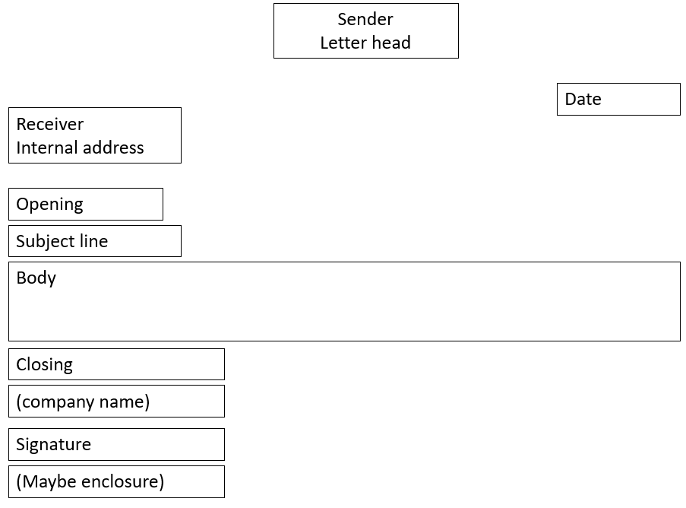

Sender/receiver address:
- If you are writing to one person:
Mr/Mrs/Miss/Ms Brown
- If you are writing to several persons:
Messrs/Mesdames Brown & Smith
- If you are writing to a company:
Jones & Hones Ltd
- Street number before street name:
12 Great Ormond Street
- Postal code after name of town:
Stoke on Trent ST5 7BT
Date:
- 16 August 2017 (BrE)
- August 16, 2017 (AmE)
Subject line:
- A heading that states what the letter is about:
Enquiry for smoothies
Signature
- Name + title
Janet Jones
Purchasing Manager

Sample letter
Letterhead: sender

Burger Green
Solskrænten 8
8000 Århus C
www.burgergreen.com
Internal address
receiver
13 February 2017
Better Taste
7 Brackenbury Road
London W6 0BA
United Kingdom
Date
Opening salutation
Dear Sir or Madam
Enquiry for smoothies
Subject line
We found your advertisement for organic smoothies on the internet. As more of our customers ask for organic food products, we think that your products will fit very well into our concept.
Burger Green is a chain of alternative fast food restaurants in Denmark with focus on ecology and healthy diet.
We are especially interested in your fruit smoothies and would therefore like you to send us information about your selection of these and a pricelist.
For your information we enclose a booklet in English about our restaurants.
If your terms are reasonable, we think we will be able to place regular orders with you.
We look forward to hearing from you.
Closing salutation
Message
Yours faithfully
Brian Sørensen
Purchasing Manager
Signature
Encl.
Enclosure

Source: Benedikte Herold Jensen. That’s Business. Øknom, 2012

Rules: layout emails

Header

Subject line

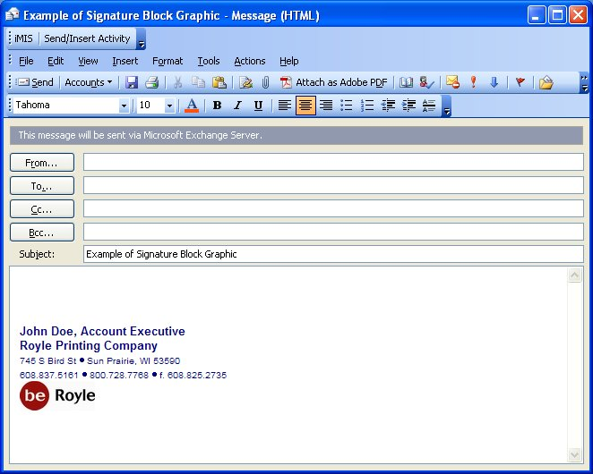
Signature block
Message

Enquiries

What do you use an enquiry for?
- Ask for information about the product
- Ask for services you consider buying
- Ask about price
- Ask about quality
- Ask about terms of business
- Ask for a brochure
- Ask for a pricelist

Useful phrases
- time of delivery
- terms of payment
- grant a discount
- the latest prices
- further information

- We got your name from one of our business connections.
- We found your company on the internet.
- Would you please send us information about time of delivery and terms of payment?
- Do you grant any quantity discounts?
- Please send us your most update catalogue with the latest prices.
- Please do not hesitate to contact us for further information
- We are looking forward to hearing from you
- We look forward to hearing from you

Exercise 1

Task:
- Read the message below.
- Find the introduction. How is it done?
- How many paragraphs does the body consist of?
- Which words help creating coherence?
- Can you spot the classic standard phrase used for ending a letter politely?
- Does the opening salutation match the closing salutation?

Dear Ms Black
I am writing in response to the advertisement I saw for your English school in ”World Teens Today” magazine. I am interested in doing one of your courses, and I would be grateful if you could provide some further information.
Firstly, it says in the advertisement that the courses are two weeks long. Would it be possible to do a three-week course? I would also like to know how much your courses cost exactly.
Secondly, your advert mentions accommodation with host families. Could you tell me if I would be staying on my own with the host family or if there would be other students staying there as well?
Finally, I have a question about the social programme. Would you mind sending me more details about this? I am very keen on sport, and I would like to know if there are any sports activities included in the social programme.
I look forward to hearing from you.
Yours sincerely
Lili Song

Exercise 2: Write an email 1

Group work
At school, you have seen an advertisement for a summer school in Britain in July 2018. As you are interested in studying English in the UK and improving your English, you write an enquiry for British Council, asking for information.
Read the advertisement below carefully and take notes of what you would like to know more about.
Write the enquiry in English.
Remember to use the rules of business communication.
“Post” the email to your teacher in Lectio (i.e. upload the file to Lectio in the English “Theme 2 Global Business” folder).
Duration: 30 min.

British Council Summer School July 2018

Come and study English at a top British language school!
- Two-week courses for all levels
- A selection of top schools all over Britain
- Highly qualified, experienced teachers
- Apply for a scholarship to cover tuition fees
- Accommodation with host families
- Extensive social programme
For further information, contact Jane Robinson: j.robinson@bho.britishcouncil.org

Assignment: write a letter

You have just received a reply from British Council giving you the information you requested in your enquiry. E.g. you have been told that British Council offers scholarships for their language schools in Edinburgh, Bath, Canterbury, Brighton and London.
You find the information satisfying and decide to apply for the scholarship covering the tuition fees. To be considered for the scholarship, you are asked to write a letter telling about yourself, explaining how such a summer course would make a difference to you. This information will be used to decide whether you are eligible for the scholarship but also to pair you with the right host family.
Therefore, you write a letter to the British Council.
In the letter you:
- Briefly introduce yourself
  - Your family
  - Your hobbies
- Tell about your previous experiences with English
  - Have you been to Britain or other English-speaking countries before?
  - Do you have English-speaking friends or relatives?
  - Which ways do you prefer to work in your English lessons?
  - What is most difficult to learn? What is the easiest?
- Argue why you need this course? Why would it make a difference to you?
- Tell which language school in the UK you would prefer to go to - and why!
- … other relevant information

Sender: Use your own address.
Receiver:
Jane Robinson
British Council
10 Spring Gardens
London SW1A 2BN
United Kingdom
Number of words: 350-450

Orders

Definition:
- When you want to buy something from a company, you place an order
- Sometimes the order is written as a business letter
- Often companies have an order form – and today you can place many orders online in a web shop
- If you use an order form, you write a covering letter and enclose the order form

Useful terms:
- Place an order with a firm
- Place an order for these goods
- You may expect substantial orders from us
- Your order of 23 March for…
- We would be pleased to receive your order
- Execute the order for…
- Make the goods to order
- This order is subject to our General Terms and conditions

Example
Neal & Co
100 New Street
London E17 7LD
United Kingdom
2 May 2008
Mr Jens Mikkelsen
Slettevej 25
DK-2610 Rødovre
Dear Sir
Thank you for your letter of 30 April with your quotation for dolls. We also want to thank you for the dolls you have sent us.
We have compared your prices with those or our other suppliers, and we are pleased to inform you that we find your quotation competitive.
Accordingly, we enclose our order for 500 of your DANNY DOLLS on the terms mentioned by you.
Yours faithfully
NEAL & CO
Encl.

Sales letters

Sales letters are sent to target groups which you find relevant for your product.
Sales letters are sent in order to expand the number of customers, to promote special offers, or to promote mail order companies.
The principles of AIDA are useful when composing a sales letter:
- Attention: catching headline and phrases
- Interest: information and promotion of the articles
- Desire: appeal to customers’ needs, i.e. prestige, status, security, money = create a need
- Action: suggest immediate response

How to write a sales letter:
- At the top of your sales letter, use a strong headline that states the most important benefit you are offering. This headline should be bold and a larger font size than the font size you use for the body text in your sales letter.
- When writing your sales letter, use a friendly conversational style. Formal, but at the same time write your sales letter as if you were talking to your best friend.
- Your sales letter needs to explain the benefits your potential customer will receive. Understand that everybody cares about one thing in life - "What’s in it for me?" Put yourself in your customer’s shoes and ask yourself, "If I was receiving this letter, why would I want to buy the product or service being sold? What’s in it for me?"
- Ask your prospect customer to take action such as to call you for more information, to visit your website, to complete and order form and mail you a check, etc. If you do not ask your prospects to take action, they won’t.
- Include testimonials from customers. Testimonials are one of the most powerful sales tools available, so always include at least one testimonial in your sales letters.
- Use a P.S. in your letter and restate your most power benefit and sales offer in it. Most people will read a P.S. first before reading the sales letter, so it is important to make your P.S. have a very strong sales message and a call to action.
- Make sure to include all of your contact information - telephone number, fax number, email address, postal address, and your website address.

Sales letter sample

MUSIC WORLD
Musikeksperten
Copenhagen
4 August 2007
Dear Sirs
We have just managed to buy a quantity of electric guitars at a very low price. Therefore, we have prepared a favourable / advantageous offer which our regular customers can make use of.
The guitars in question are branded goods of a very high quality, and as we sell them at half price, this is an offer you cannot refuse/turn down/decline. We offer FANDER guitars, model JL400 at £/GBP 690, while stock lasts. It is a well-known fact that this model is extremely popular so therefore this offer is quite unique.
As you are one of our regular customers, we hope that you will avail yourself of the offer. When a branded good like FANDER is on offer, the customers flock to the store, and this is something which benefits the turnover. Such an offer also gives a lot of positive publicity. Therefore, we can only encourage you to accept the offer and preferably fast.
If you are interested, we ask you to contact us per telephone or fax and place your order. And let us remind you that first come, first served. We look forward to hearing from you.
Yours faithfully
MUSIC WORLD

Exercise 3

Write a sales letter/email for one of the products you can find in class. The letter/email is going to be sent to a specifically selected group of customers.
Use today’s date and sign with your own name. Use the AIDA model to structure your letter.

Memorandum (memo)

What is a memorandum?
- A written piece of communication in a business organisation
- Between:
  - Employees in various departments
  - Management and employees
- Contents:
  - Giving or asking for information
  - Confirmation of agreements, meeting, events
  - Assigning people to various tasks in the office
  - Reporting results of surveys, interviews, etc.

Example:
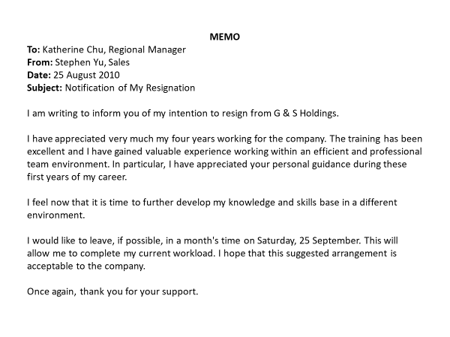

Exercise 4

On the computer, as a group, write a memo from the principal of your college to the president of the students’ union complaining about the amount of litter (rubbish) thrown in the yard during the fine weather. The principal wants the president’s suggestions as to how the problem can be tackled.

