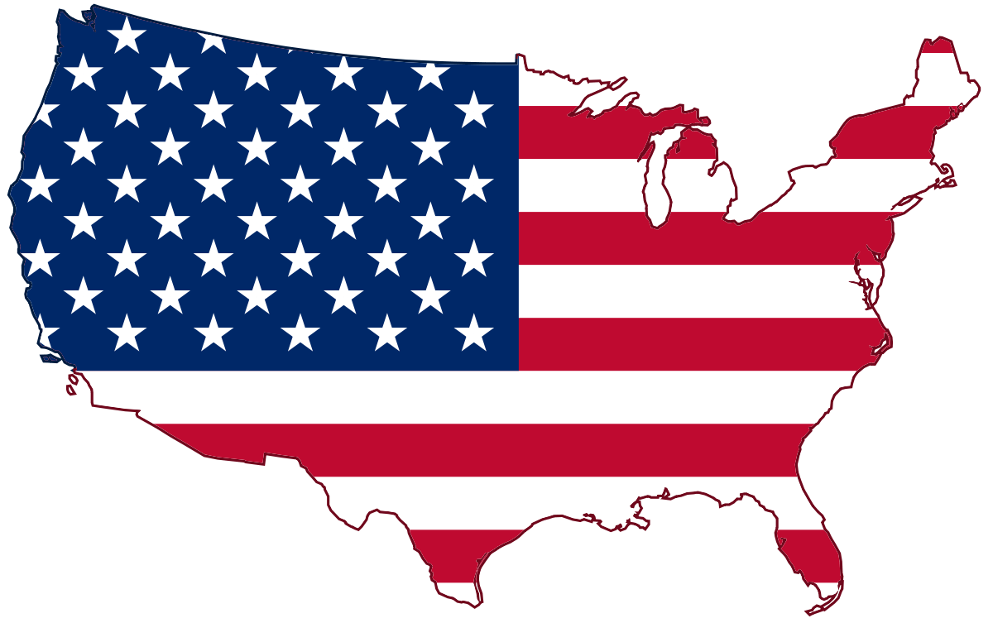
The USA
Facts on the US – English Level B
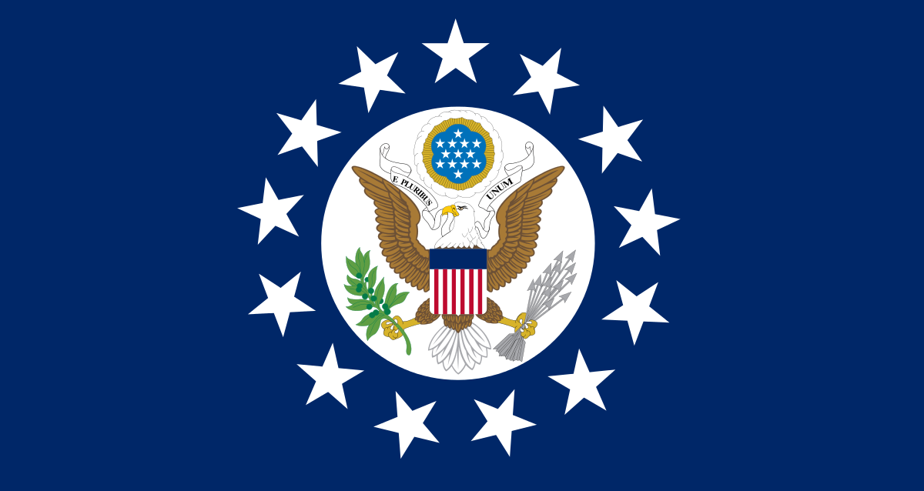

Table of contents
Goals (in Danish) 2
Test your British/American 3
Pre-task 1 3
Pre-task 2 4
Questions to the US 4
Task 1 4
Description via map of the US 6
Task 1: 6
Appendix 1 8

Goals (in Danish)

Faglige mål
Sprog, tekst og kultur
- orientere sig i et engelsksproget stof, herunder udøve kildekritik og dokumentere brugen af forskellige informationskilder ̶¨
- anvende faglige opslagsværker og øvrige hjælpemidler

Kernestof
- tekster, der tilsammen beskriver væsentlige sproglige, historiske, kulturelle og samfundsmæssige forhold i Storbritannien eller USA

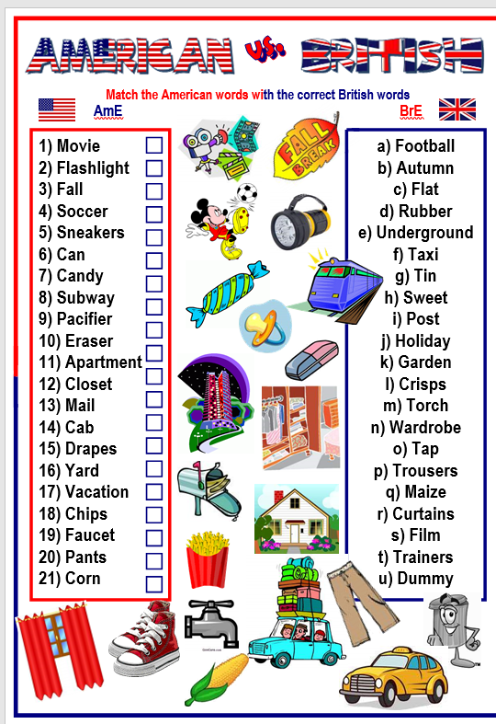
Test your British/American

Pre-task 1

- How would you describe the typical American? Use five adjectives to describe “your typical American”.
- Explain each adjective, and why you chose those ones.

Pre-task 2
- What do you know about America? – Fill in the mind map – fill it in with as many things you can think of regarding the US.

USA

- Select six words from your mind map and explain them to the person sitting next to you. You are to explain why you chose them.

On the next page, you are to answer some general questions about the US.

Questions to the US

Look up the answers to the below questions regarding the US. Your findings are to be shared afterwards in class.

Task 1
Find the answers to the below questions. You may use the internet to find answers, but you may not use Wikipedia. A recommendation could be to search on Britannica.com for some of the information.
General questions:
- What is the capital of the US?
- Who is the president of the US?
- How many live in the US?
- How many states are there in the US?
- Which countries border to the US?
- Who discovered the US, and when?
- Who was the first president of the US?
- What is “The Declaration of Independence”, when was it written and by whom?
- Who are the “original” people of the US? Tell a bit how they were/are treated.
- Find out about the immigration waves to the US! Tell about them.
  - You can get help from this link: https://immigrationtounitedstates.org/603-immigration-waves.html
- What beliefs (religion) do the Americans have?
- Find out the number of ethnic distribution.

Next, you will find a map of the USA. You will be working with this map and some tasks to the map.

Description via map of the US

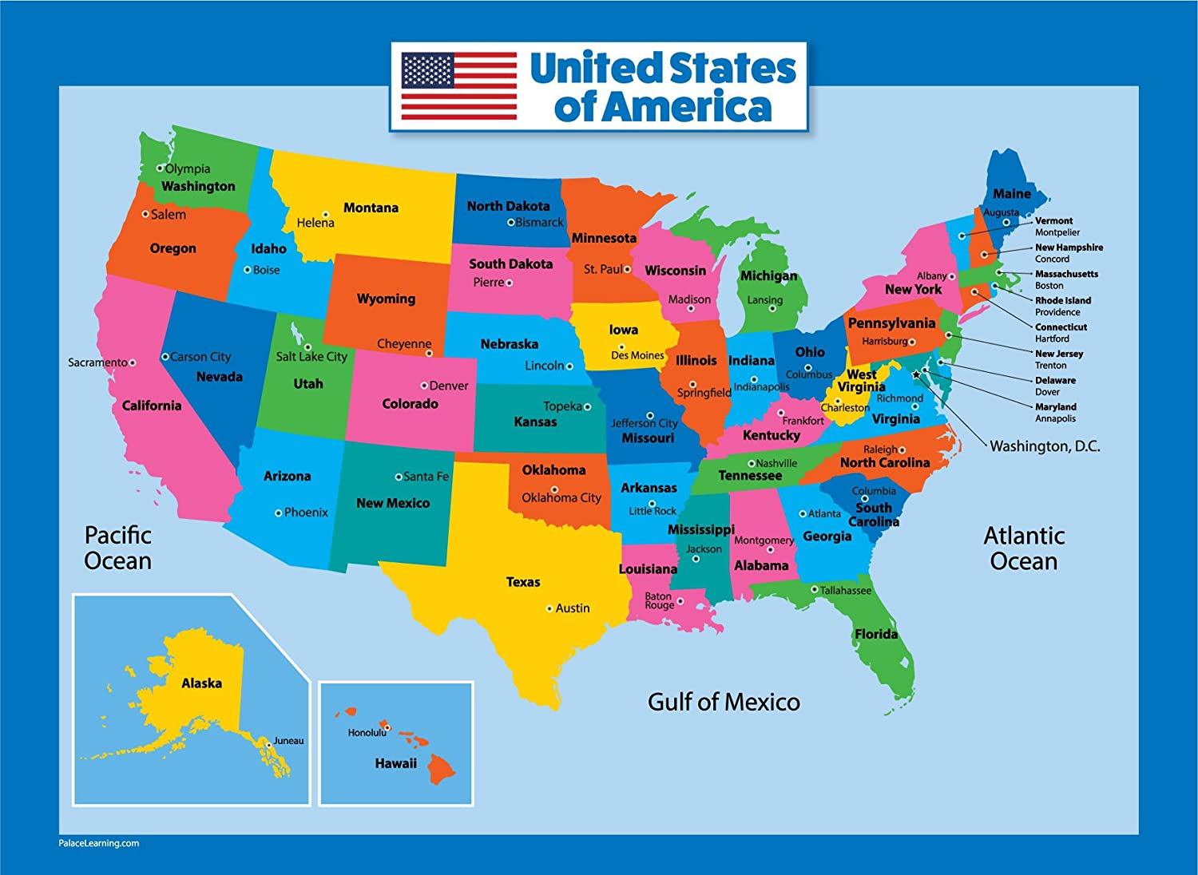

Task 1:
Group exercise
In your group, you are to decide on who takes which states. No one is allowed to have the same states. You are to choose five states you think could be interesting to know more about. From the below questions you are to make a short presentation in PowerPoint of your chosen states. Remember to include pictures and to use the Power Point as a tool. DO NOT READ ALOUD from your screen! Duration of the presentation: 25 minutes (approximately 5 minutes per state).
Again, you are not allowed to use Wikipedia as a source.

- Find at least two interesting facts, i.e., a historical incident, a geographical site etc. You may choose what you find the most interesting from the states you have chosen.
- How many live in these states?
- What political direction do the five states, you have chosen, have? (see appendix below)
- What is the weather like in your chosen states?
- What is the time difference between DK and your chosen states?
- Where on the map, i.e., Southeast, can one find your five states – show us?
- What is the “capital” of your states?
- Name two famous people who come from your chosen states (if there are any).
- Find which religion exists in your state, i.e., 50% belong to the Catholic Church etc.
- Find some recent news (it does not have to be long) from your states to talk about.
When you are to present your PowerPoint will be agreed with your teacher.

Appendix 1

American values differ to some extent according to where you live. Regional differences might appear somewhat stereotypical, but it seems relevant to include this outline.
BEING DIFFERENT ACCORDING TO REGION

 | Northeast  (Maine, New Hampshire, Vermont, Massachusetts, Connecticut and Rhode Island) | Demography: This area is densely populated. It is one of the areas with the most people per square mile.  Industry: Manufacturing and trade, tourism  Political view: Liberal, value education, comfortable with government regulation, tendency to vote Democratic  Character traits: Uninhibited, temperamental
 | Mid-Atlantic region  (New York, New Jersey, Pennsylvania, Delaware, Washington, D.C. and Maryland) | Demographics: Diverse population, urban, densely populated  Industry: Manufacturing and shipping, heavy industry  Political view: Value education, tendency to vote Democratic  Character traits/values: Relaxed, creative people, care about health, global outlook
 | South  (Virginia, West Virginia, Kentucky, Tennessee, North Carolina, South Carolina, Georgia, Florida, Alabama, Mississippi, Arkansas, Louisiana, and parts of Missouri, Texas and Oklahoma) | Demographics: Less educated, many people are not well-off economically. Some of the poorest cities in the USA are located in the South.  Industry: Farming, manufacturing, tourism  Political view: More conservative, against federal government control. Traditionally most of the states have voted Republican, but some of them have recently become swing states alternating between the two major parties  Character traits/values: Importance of family, traditional life style, hospitality, friendliness, relaxed attitude, not too concerned about health
Midwest  (Ohio, Michigan, Indiana, Wisconsin, Illinois, Minnesota, Iowa, parts of Missouri, North Dakota, South Dakota, Kansas, Nebraska and eastern Colorado) |  | Demographics: Not as densely populated as other areas  Industry: Farming as one of the main industries, industry and manufacturing in the cities  Political view: Middle class, dislike of government intrusion. Mostly these states vote Republican, but some states can be decisive in elections  Character traits/values: Traditional values, friendly, honest and straight-forward people

Southwest  (Western Texas, parts of Oklahoma, New Mexico, Arizona and Nevada) |  |  | Demographics: Populated in the cities, Spanish influence  Industry: Oil, mining, agriculture (livestock)  Political view: Texas, Oklahoma and Arizona are usually Republican  Character traits: Least European influence, but influenced by native American culture. Relaxed and creative people, not particularly extrovert
 | West  (Western Colorado, Wyoming, Montana, Utah, California, Nevada, Idaho, Oregon, Washington, Alaska and Hawaii) | Demographics: Not densely populated outside the major cities, mixed immigrants, Spanish influence in the south  Industry: Agriculture, tourism, oil, mining  Political view: Liberal, mostly Democratic  Character traits: Least traditional, tolerant of change, healthy, educated, relaxed, creative

Source: Being American, IBog, Systime, Mette Holm

