THE 50 STATES ASSIGNMENT
Dette billede efter Ukendt forfatter er licenseret under CC BY-SA

Groups for Monday 29th of April and Wednesday the 1st of May: Timeframe: 3 less. Oral presentations: last 3 less on Wednesday – 12-14 minutes per group
- 7 guests from Germany
- 5 globalization students
- hh1 b 5 students
- hh1 b 4 students
- hh1b 4 students
- hh1c 3 students
- hh1c 3 students
- hh1c 3 students
- hh1 c 4 students
- hh1 c 4 students

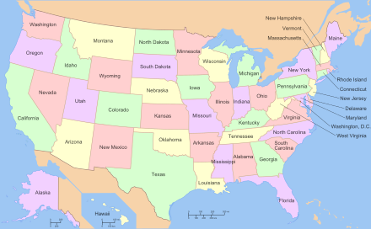
Dette billede efter Ukendt forfatter er licenseret under CC BY-SA

