Exam – English B

Theme: Innovation & Entrepreneurship
Text: Pip & Nut founder: 'At first, all you have is a dream, so learn how to sell it'
The Telegraph – 11 December 2017

- Give a summary of the article

- Account for some of the main challenges Pippa met during her start-up

- Make an analysis of the text and discuss the pros and cons of starting your own business

- Draw parallels to relevant material discussed in class

Ved den mundtlige prøve lægges der vægt på, at eksaminanden:

- behersker et sammenhængende og forholdsvis flydende engelsk med relativ høj grad af grammatisk korrekthed
- giver en klart sammenhængende præsentation
- analyserer, fortolker og perspektiverer prøvematerialet med anvendelse af fagets analytiske begreber og metode
- anvender viden, der er opnået i arbejdet med det studerede emne.

Der gives én karakter ud fra en helhedsbedømmelse af eksaminandens præstation.



Pip & Nut founder: 'At first, all you have is a dream, so learn how to sell it'

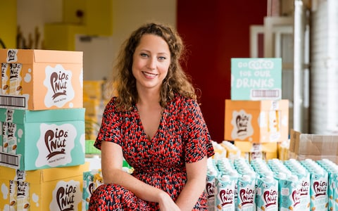'
Pippa Murray, founder of Pip & Nut Credit: Pip & Nut/Iona Wolff
Matthew Caines
The Telegraph 11 December 2017

Pippa Murray says that it hasn’t always been a smooth ride, with difficulties securing a suitable food factory – here; she explains how one of her best business results came from necessity, not choice.
It was in search of a suitable post-run snack that Pippa Murray decided to have a crack at launching her own nut butter business. "There wasn't a profound light-bulb moment, where I woke up one morning and thought: nut butter, that's it!
"Things chipped away at me for a while," explains the 29-year-old Pip & Nut founder, who does a lot of running and marathon training. Craving a boost after a session, she would always turn to peanut butter. "It helped with the exercise, being high in protein, but it was also delicious – the perfect treat," says Murray.
The issue was that many of the peanut butters at her local supermarket contained lots of sugar and palm oil, which is high in saturated fat and the production of which has led to deforestation. "I felt like these brands weren't being true to consumers."
There was room on the shelf for a more innovative, healthier and transparent product, thought Murray. "I bought a blender and messed about in my kitchen, creating some dodgy batches on the way, ”she jokes.
Previously a theatre producer at London's Science Museum, the founder admits that she had no knowledge of food production. "It's tough to work out, because factories don't exactly put themselves out there," says Murray, who spent two years inquiring, researching and developing her home-blended butters. She started selling at London's Maltby Street market, gaining some initial customer feedback. "Friends and family are a good for first opinions, but eventually, you're going to want the general public to be brutally honest with you," she says.
Finally content with the three nut butter flavours that would become her launch products (peanut, almond, and coconut and almond); Murray graduated from her kitchen to full-scale production. "Finding a factory was like searching for a needle in a haystack: I cold-called people, visited lots of unsuitable industrial spaces, and had countless conversations about making my product," she says. You get a lot of rejections."
In 2015 and following an eight-month search, Murray found her perfect production partner. The process of securing that first manufacturer is the biggest barrier to entry for start-up food and drink firms, she thinks. "At that stage of your journey, all you have is a concept, so you're not appealing; you have no product volume or track record."
But what you do have, she adds, is a dream – so learn how to sell it. That means being articulate about your passion, vision and long-term goals. "It's all about trust because, likewise, you need to feel comfortable that a factory is going to do your product justice and make it to a high quality. It's all about having a great relationship."
[…]
Hiring and retaining staff has also proved testing. "You must find staff who are sympathetic to your start-up status," advises Murray, who leads a team of nine full-time and two part-time staff.
"Hire people who understand that things will be chaotic and that they need to be flexible, doing not just their job, but other bits of other people's jobs, too.
"There's a perception that working at a start-up is all beers on a Friday, and while it is that, it's also lots of hard work, uncertainty and risk, so communicate that to recruits."
Away from the challenges, there have been successes – and one of the brand's smartest decisions didn't seem significant to Murray at the time. When it launched in 2015, Pip & Nut sold into premium, independent stores – from the smaller ones to Selfridges, Fortnum & Mason and so on.
It wasn't out of choice, but necessity, being the only route to market at the time.
[…]
https://www.telegraph.co.uk/connect/small-business/pip-and-nut-pippa-murray-how-to-sell-your-dream/

