What Happened in the Parkland School Shooting
By Sarah Almukhtar, K.K. Rebecca Lai, Anjali Singhvi and Karen Yourish
New York Times: 24 April 2018
New details released Tuesday by the Florida Department of Law Enforcement, revealed how a gunman armed with a semiautomatic AR-15 assault rifle and “countless magazines” killed 17 people at his former high school in Parkland, Fla., in February.
release
frigive
reveal
afsløre
assault
angreb
dismissal time
før de fik fri fra skole
purposefully
målrettet
freshman
førsteårs
discard
skille sig af med
blend in with
blande sig med

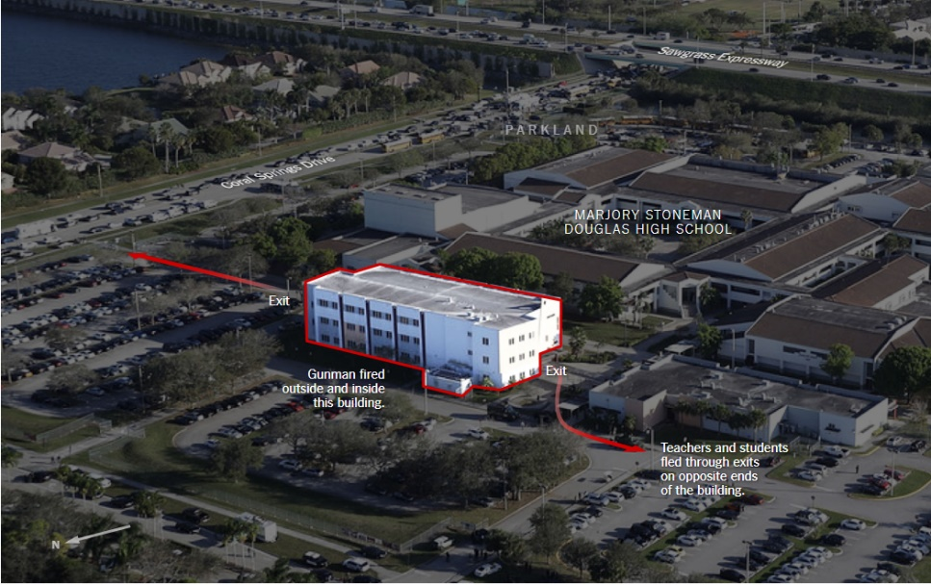
The heavily armed man, identified as Nikolas Cruz, 19, arrived at the school in an Uber at 2:19 p.m., shortly before dismissal time. He made his way “purposefully” toward the freshman building, said a police report released Thursday.
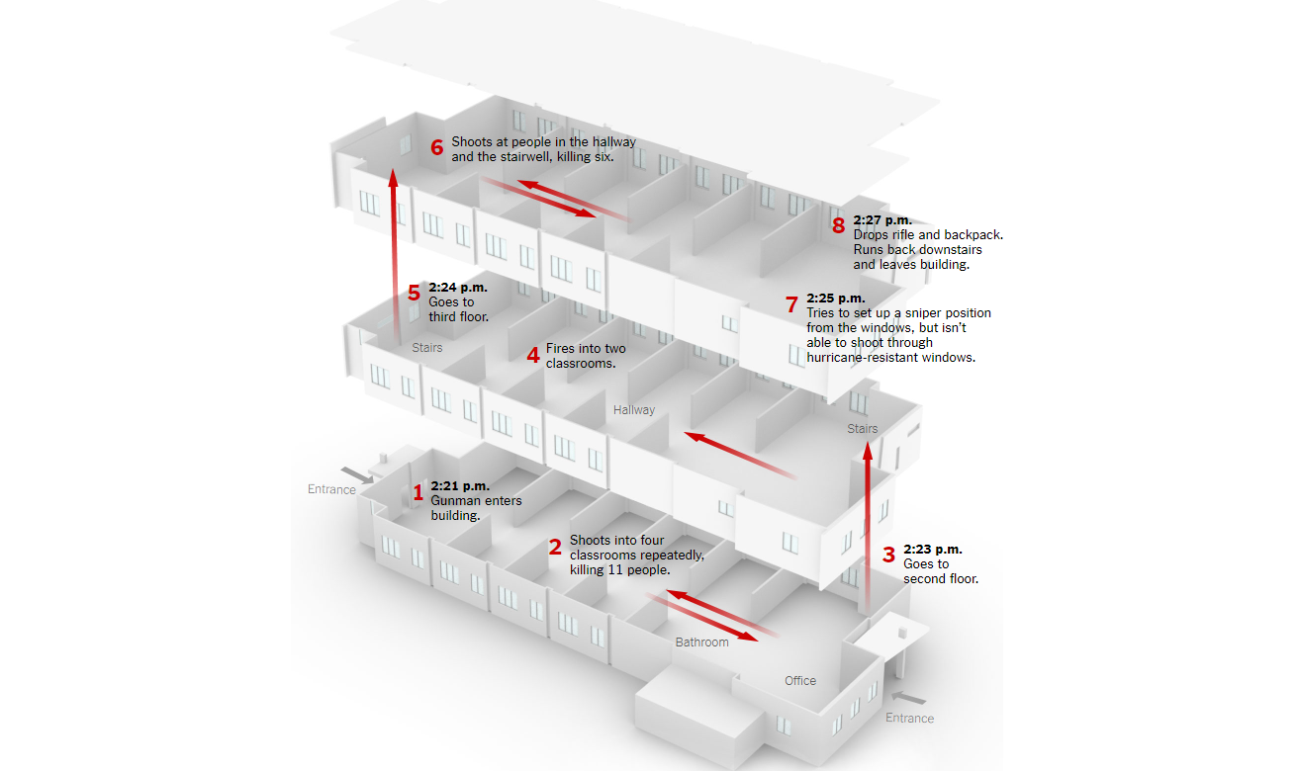
According to details described by authorities, Mr. Cruz shot people in the hallways and inside classrooms. He eventually discarded the rifle, a vest, and ammunition in a stairwell, and blended in with fleeing students to get away.
On the third floor, students were leaving their classroom when they heard gunshots, according to several students.
They ran back to their classroom, and their teacher, Scott Beigel, was shot and killed as he tried to lock the door, the students said.
crouched
sammenkrøbet
expelled
smidt ud af
conceal
skjule sig
residential
beboelses
As the gunman walked through the building, he shot into classrooms where students were crouched in corners and hiding in closets. After the shooting ended, students ran out of the building flanked by heavily armed police officers.
There are 30 classrooms in the building, which was originally built only for freshmen but is now used by students in other grades as well, said Melissa Falkowski, a teacher at the high school. All told, there are usually about 900 students and 30 teachers in the building on a typical school day.
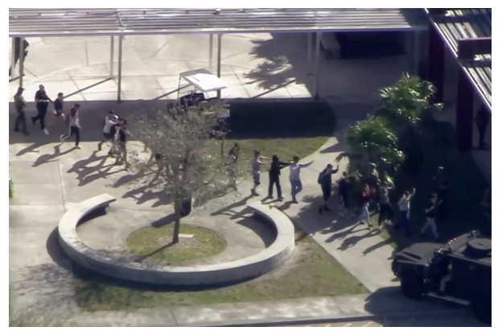
Mr. Cruz, who had been expelled from the school, concealed himself in the crowd and was among the hundreds of people fleeing the building, authorities said. After leaving the school, he walked to a Walmart and bought a drink at a Subway, according to authorities. At 3:41 p.m., he was arrested by the police as he walked down a residential street in Coral Springs, just a few miles from the school. He was taken to a nearby hospital before being released into police custody.
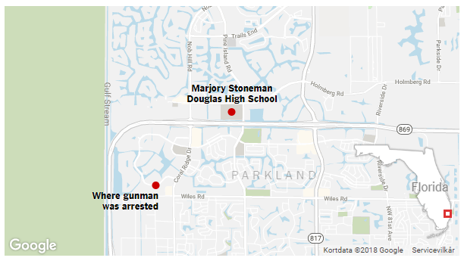

The 2nd Amendment
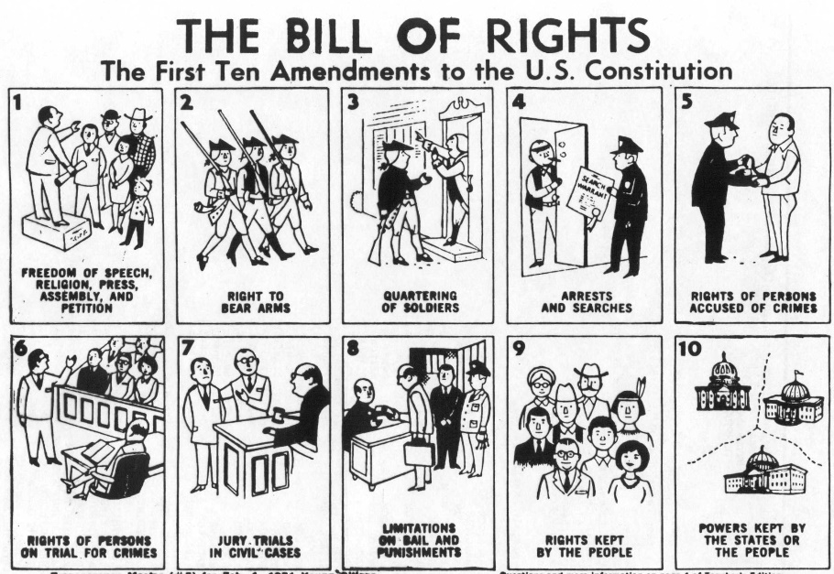
The Second Amendment was part of the Bill of Rights that was added to the Constitution on December 15, 1791. This amendment protects the rights of citizens to "bear arms" or own weapons such as guns.
The Second Amendment has become a controversial amendment in recent years. Many people want more laws to prevent people from owning guns. They think this will help prevent shootings and keep criminals and mentally ill people from getting guns. Other people want to keep this right and not have it limited. They think that having guns will allow them to protect themselves from criminals and the rise of a tyrannical government.
The Text of the Second Amendment
” A well regulated Militia, being necessary to the security of a free State, the right of the people to keep and bear Arms, shall not be infringed.”

What Does the Second Amendment Mean?

Militia: During early American history, all males who were between the ages of sixteen to sixty were required to be a part of the local militia in their towns and communities. Almost everyone during this time used and owned guns. The few men who did not use or own a gun were required by law to pay a small fee instead of participating in the military services of their communities. These militias defended the communities against Indian raids and revolved, acted as a police force when it was needed, and was also available to be called upon to defense either the State or of the United States of America if it was needed.

Bear arms: When the Second Amendment was written, arms meant weapons. The word arms did not necessarily only mean guns, but it definitely included guns. The Second Amendment did not specifically explain what categories or types of arms nor did it list what weapons were considered arms. When you bear arms, this means you physically carry weapon. You may have arms in your home as well as on your person.

Shall not be infringed: The Second Amendment does not grant any right to bear arms. Furthermore, the rest of the Bill of Rights does not describe any right to do so. These rights are thought of as natural rights or God-given rights. In the Bill of Rights, the Second Amendment is just a reminder to the government that they should not try to stop people from having this right.

Source: https://kids.laws.com/second-amendment and https://govbooktalk.gpo.gov/2013/12/13/quiz-and-history-for-bill-of-rights-day-december-15/

What you should know about the March for Our Lives
By Dakin Andone
CNN: March 23, 2018

Survivors of last month's deadly school shooting in Parkland, Florida, are preparing to take their fight for stricter gun control laws to Washington.
This week's March for Our Lives is the culmination of a monthlong effort to honor the 17 students and faculty members killed at Marjory Stoneman Douglas High School, and rally Americans across the United States to say enough to gun violence.
With momentum from the National School Walkout still going strong, students are demanding that their voices be heard.
Here's what you should know about the March for Our Lives
What is it?
March for Our Lives is a demonstration created and organized by #NeverAgain, a group of students who survived the February 14 shooting at Marjory Stoneman Douglas High School. Everytown for Gun Safety, a gun control advocacy group, is helping the students plan and coordinate the event.
After the shooting at Stoneman Douglas -- the eighth mass school shooting this year -- organizers are calling on lawmakers to address the issue of gun violence in American schools by implementing comprehensive gun control legislation.
According to a petition on the event's website, March for Our Lives has three primary demands:
- Pass a law to ban the assault weapons frequently used to carry out mass shootings
- Stop the sale of high-capacity magazines, restricting the amount of ammunition
- Close loopholes in America's background checks and implement laws that require background checks on every gun purchase, including those that occur online or at gun shows
When is it?
The main march will take place in Washington on Saturday, March 24. It will kick off at noon, when participants gather on Pennsylvania Avenue, just blocks away from the Capitol.
Hundreds of sister marches are also taking place across the country and around the world.

Naomi Wadler: 'We know life isn’t equal for everyone', March for Our Lives - 2018

TRANSCRIPT
24 March 2018, Washington DC, USA
My name is Naomi, and I’m 11 years old. Me and my friend Carter led a walk-out of elementary school on the 14th. We walked out for 18 minutes, adding one minute to honor Courtlin Arrington, an African-American girl who is the victim of gun violence in her school in Alabama after the Parkland shooting.
acknowledge
anerkende
vibrant
livlig
equal
lige
urge
bede om
disproportionate
uforholdsmæssig
narrative
fortælling

I am here today to represent Courtlin Arrington. I am her today to represent Hadiya Pendleton. I am here today to represent Tiana Thompson, who was just 16 and shot dead in her home here in Washington DC.
I am here today to acknowledge and represent the African-American girls whose stories don’t make the front page of every national newspaper, whose stories don’t lead on the evening news. I represent the African-American women who are victims of gun violence, who are simply statistics instead of vibrant, beautiful girls full of potential.
It is my privilege to be here today, I am indeed full of privilege. My voice has been heard. I am here to acknowledge their stories, to say they matter, to say their names, because I can, and I was asked to be. For far too long, these names, these black girls and women, have been just numbers. I’m here to say, ‘Never again’ for those girls, too. I am here to say that everyone should value those girls, too.
People have said that I am too young to have these thoughts on my own. People have said that I am a tool of some nameless adult. It’s not true. My friends and I might still be eleven, and we might still be in elementary school, but we know. We know life isn’t equal for everyone, and we know what is right and wrong. We also know that we stand in the shadow of the Capitol, and we know that we have seven short years until we, too, have the right to vote. So I am here today to honor the words of Toni Morrison: ‘If there is a book that you want to read but it hasn’t been written yet, you must be the one to write it.’ I urge everyone here and everyone who hears my voice to join me in telling the stories that aren’t told, to honor the girls, the women of color who are murdered at disproportionate rates in this nation. I urge each of you to help me write the narrative for this world and understand, so that these girls and women are never forgotten.

Emma Gonzalez: 'Six minutes, and about 20 seconds', March for Our Lives - 2018

TRANSCRIPT
24 March 2018, Washington DC, USA
Six minutes, and about 20 seconds. In a little over six minutes, 17 of our friends were taken from us, 15 more were injured, and everyone, absolutely everyone in the Douglas community was forever altered. Everyone who was there understands. Everyone who has been touched by the cold grip of gun violence understands. For us, long, tearful, chaotic hours in the scorching afternoon sun were spent not knowing.
No one understood the extent of what had happened. No one could believe that there were bodies in that building waiting to be identified for over a day. No one knew that the people who were missing had stopped breathing long before any of us had even known that a code red had been called. No one could comprehend the devastating aftermath, or how far this would reach, or where this would go.
injured
såret
alter
ændre
scorching
brændende
extent
omfang
comprehend
begribe
devastating
ødelæggende
aftermath
følger
cease
holde op med
For those who still can't comprehend, because they refuse to, I'll tell you where it went. Right into the ground, six feet deep. Six minutes and 20 seconds with an AR-15, and my friend Carmen would never complain to me about piano practice. Aaron Feis would never call Kyra "miss sunshine," Alex Schachter would never walk into school with his brother Ryan, Scott Beigel would never joke around with Cameron at camp, Helena Ramsay would never hang around after school with Max, Gina Montalto would never wave to her friend Liam at lunch, Joaquin Oliver would never play basketball with Sam or Dylan. Alaina Petty would never, Cara Loughren would never, Chris Hixon would never, Luke Hoyer would never, Martin Duque Anguiano would never, Peter Wang would never, Alyssa Alhadeff would never, Jamie Guttenberg would never, Jamie Pollack would never.
[Silence] (start 2:10 – alarm 6:33 – start video 6:26)
Since the time that I came out here, it has been six minutes and 20 seconds. The shooter has ceased shooting, and will soon abandon his rifle, blend in with the students as they escape, and walk free for an hour before arrest. Fight for your lives before it's someone else's job.

